Agenda Description

Beth Outlaw and Rick Miller from Office of Research Information Services (ORIS) would like feedback on changes planned for the UW Office of Research website, https://www.washington.edu/research/, to improve accessibility. The Research Website is intended to provide research administration information for current and prospective UW faculty, staff and students. Their team wants the Office of Research website to be easily readable by screen readers and the web page title headings to conform to accessibility best practices. They are seeking feedback on proposed code changes to reach consistent HTML heading tags for custom post templates. Examples: 1) Forms & templates custom post type, 2) Announcement custom post type, and 3) Glossary custom post type

Problem Statement

The UW Office of Research website is built via WordPress. If you're not familiar with WordPress it comes with two different content types - posts and pages. ORIS built custom post types, hard-coded to display a certain way. There are 12 custom post types total with inconsistent HTML heading tags, including sometimes skipping tags.

Proposed Solution
In order to achieve consistent HTML heading tags our team plans to modify code based on if a sidebar element appears or doesn't appear on a template.
Modify the code to:
- NOT display the Post-Type-Title as H1,
- Use H1 for the post title heading,
- If there is a sidebar, use H2 for sidebar headings, and use H3 for footer headings and
- If there is a NO sidebar, use H2 for footer headings
- Not impact visual style and layout

Once code fix is implemented the Research website will have three templates for custom post types. ORIS would like feedback on the proposed code changes before implementing this code fix to reach consistent HTML heading tags for custom post templates.

Example 1: Forms & templates custom post type
This template contains a post type title, post title, sidebar, and footer

Current State
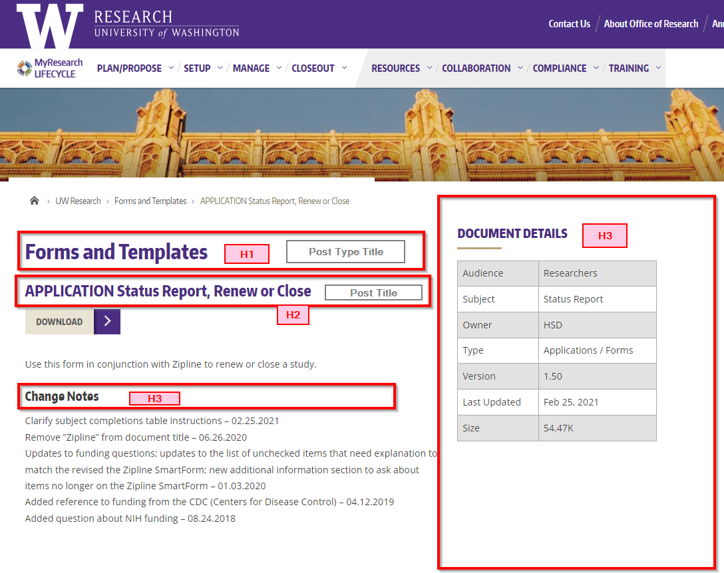

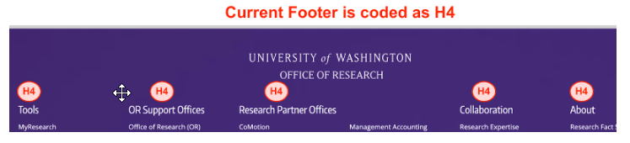

Proposed State
- Remove HTML tag from post type title and page content
- Post title = H1
- Sidebar = H2
- Footer = H3

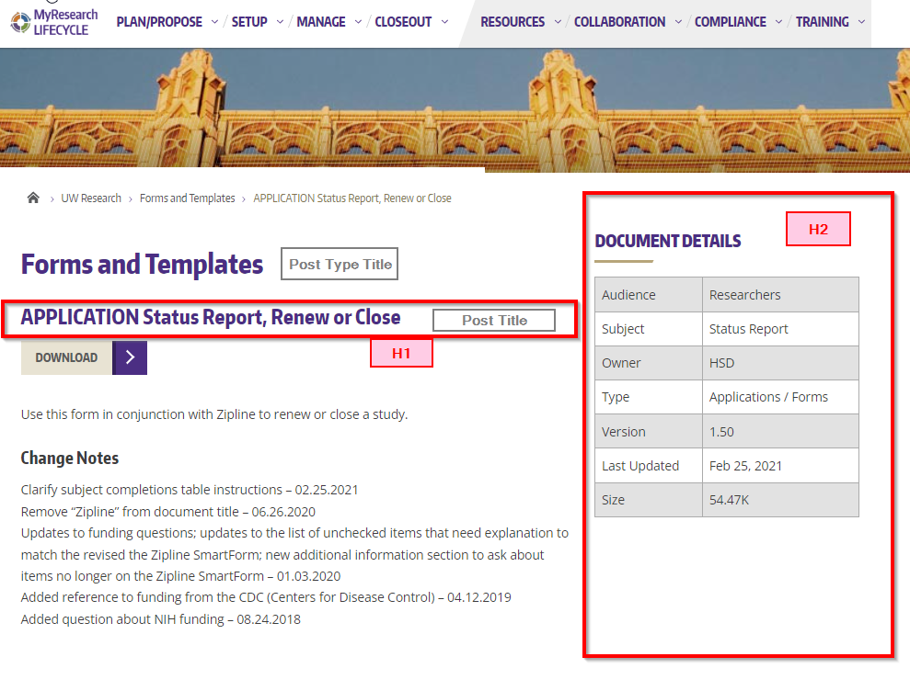
Footer coded as H3
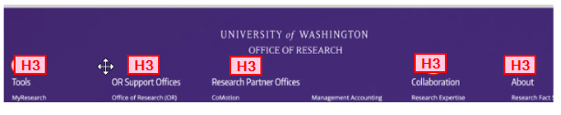

Example 2: Announcement custom post type
This template contains a post title, sidebar and footer. Missing a post type title.

Current State
This post contains
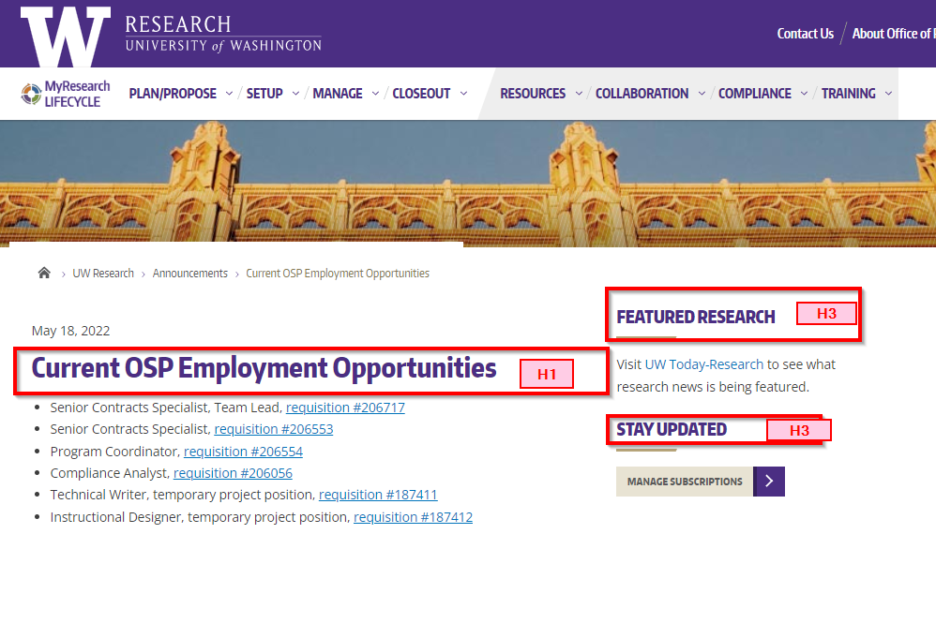

Proposed State
- Sidebar = H2
- Footer = H3
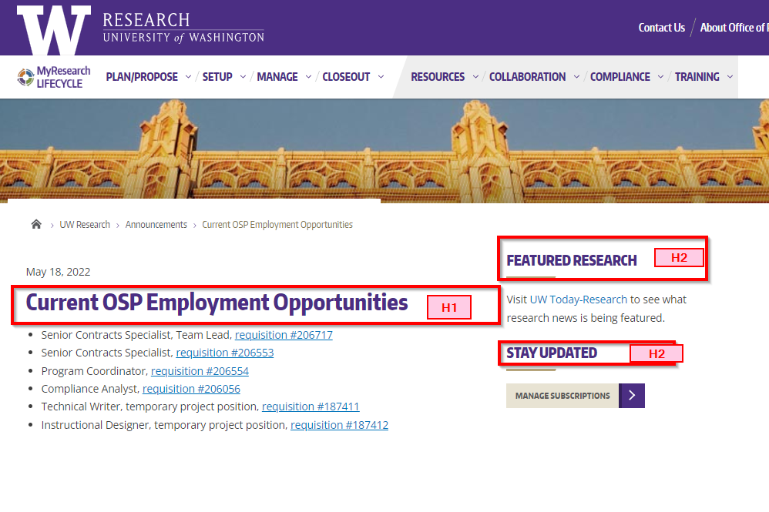
Footer Coded as H3

Example 3: Glossary custom post type
This template contains a post title and footer. Missing post type title and sidebar.

Current State
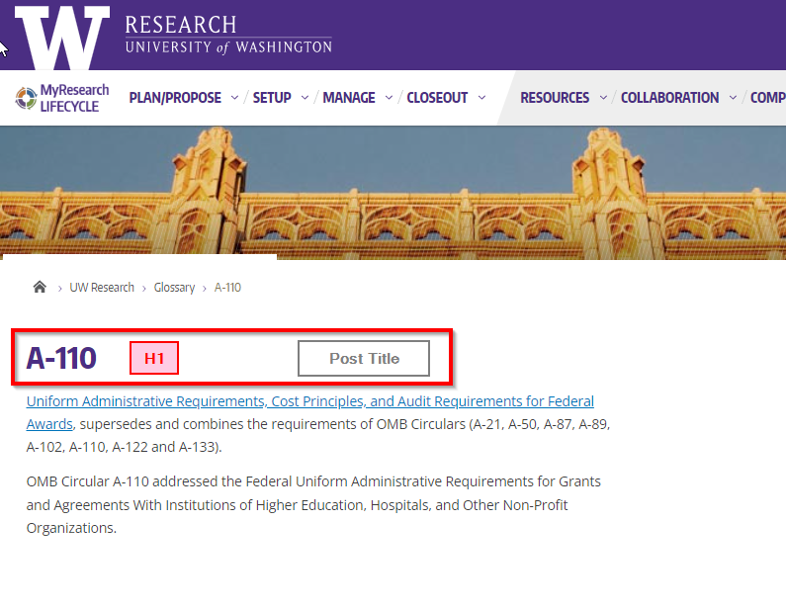

Proposed State
- Footer = H2
Footer Coded as H2
