ERIC Usability Testing Update January 2005

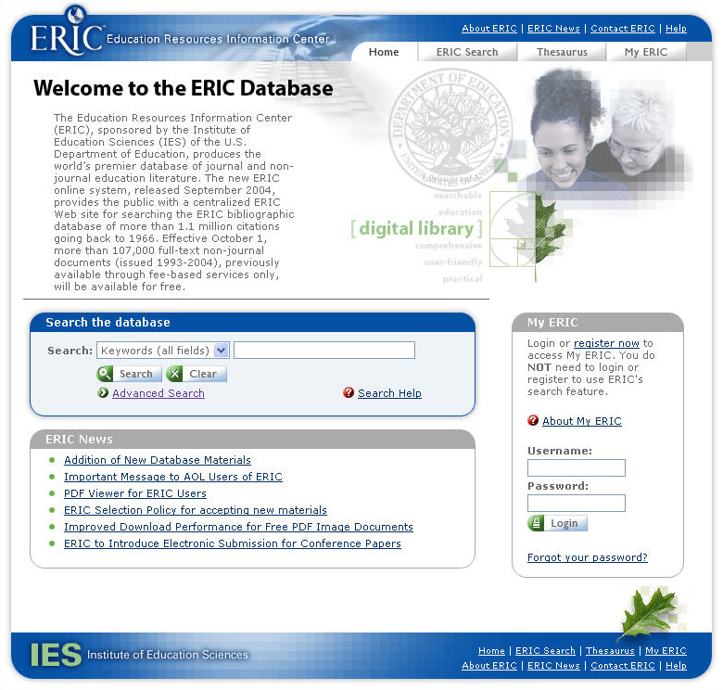
Our Mission
The Department of Education is revising the Education Resources Information Center (ERIC) http://www.eric.ed.gov/ program to achieve greater efficiency, ease-of-use, and increased availability of bibliographic and full-text material. The Department is committed to collecting ongoing feedback from ERIC users.

Computer Sciences Corporation (CSC) is re-engineering the ERIC system to help achieve these goals, and we need the help of educators, librarians, students, and researchers to make the new ERIC the best it can be. As part of the process of continuous improvement, the ERIC team is conducting a series of usability testing sessions to solicit user feedback on the Web site’s user interface.

What is usability testing?
Usability testing is a technique used to evaluate, validate and refine Web sites. It is the most effective method to determine if users can successfully navigate and easily use a Web site to accomplish their goals.

During the ERIC usability testing session the participant is asked to conduct several realistic tasks using the ERIC Web site, such as searching for documents. We take notes and video tape each session for our research purposes only. Typically, a usability test session runs one to two hours.

How can you help?
We are looking for ERIC users who would be willing to participate in these usability tests and give us candid feedback on how we can improve the ERIC Web site for you and the entire user community.

Where will the usability testing take place?
We are formulating plans for our next round of ERIC usability testing. The next round is scheduled at CSC facilities in Austin, TX and Washington, DC in March 2005. To ensure that we have a representative mix of test participants, we are also planning to conduct usability testing remotely via the internet and telephone to involve ERIC users in other locations.

Beyond March 2005, we will continue to periodically conduct usability testing sessions. Future usability testing sessions may take place in other cities besides Washington, DC and Austin, TX.

Contact Us
Please contact us if you would like to participate in usability testing in March 2005 or beyond. Please email Pete McNally (pmcnall3@csc.com) and we will add you to our list of usability testing candidates.

Thank you!

The ERIC team

