http://www.alimed.com/resources/common/user/File/InfoPak/10067%20Keyboards.pdf

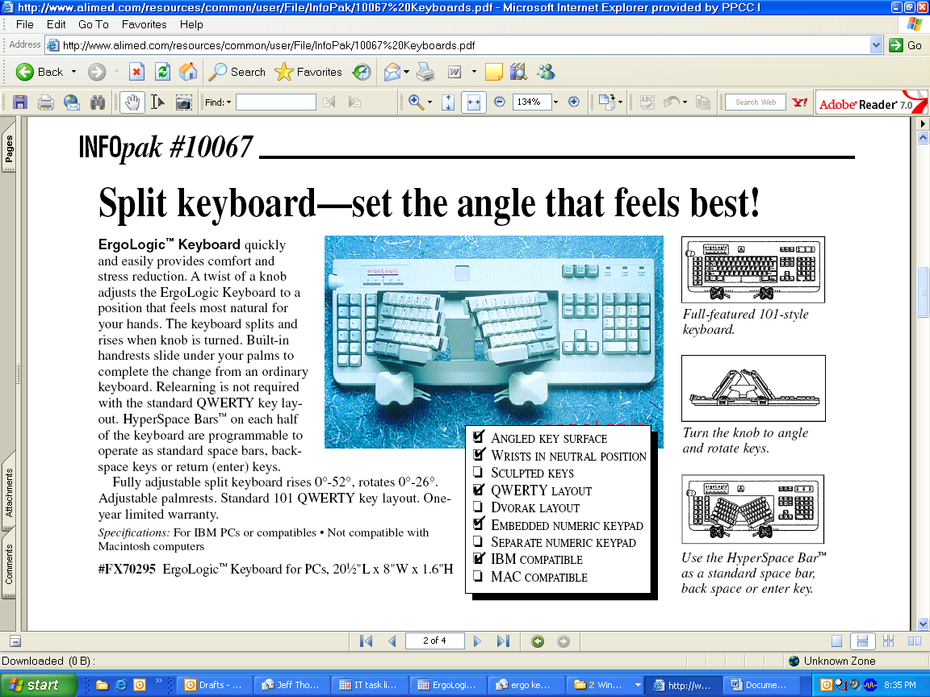

U.S. and Canada 800-225-2610 General Information 781-329-2900 Fax 800-437-2966 www. AliMed. com

