Advanced OCR

High Tech Center Training Unit

of the California Community Colleges at the
Foothill-De Anza Community College District

21050 McClellan Road
Cupertino, CA 95014
(408) 996-4636
(800) 411-8954

www.htctu.net

URL to our CC license:
http://creativecommons.org/licenses/by-nd-nc/1.0/

Creative Commons website:
http://creativecommons.org

Table of Contents
Creating the Image File 1
Abbyy FineReader 1
Interface 1
Toolbar Set-up 2
Options Set-up 2
Document Tab 2
1. Scan/Open Tab 3
2. Read Tab 4
Important! 5
3. Save Tab 5
View Tab 6
Advanced Tab 7
Check Spelling Tab 7
Customize Toolbars 8
Processing an Image (TIFF or PDF) File 9
Step One: Open an Image File or a PDF File 9
Step Two: Analyze Layout 10
Step Three: Adjust Areas 10
Step Four: Read Document 11
Step Five: Check Spelling 11
Step Six: Save the Document 12
FineReader Tips 13
Automating Tasks 14
Creating an Automated Task 14
OmniPage Pro 19
Interface 19
Document Manager 19
Configuration for Blind User 20
Toolbars 22
Options Set-up 23
OCR Tab 23
Process Tab 23
Proofing Tab 24
General Tab 25
Text Editor Tab 26
Scanner Tab 27
Processing an Image (TIFF or PDF) File 28
Step One: Load a File 28
Step Two: Run the OCR 29
Step Three: Adjust Zones 30
Step Four: Save the Document 32
OmniPage Tips 36

Creating the Image File
Although you can scan with either OmniPage or FineReader, we recommend that you scan your files to TIFF and then work with the resulting multipage image. There are a number of reasons: it preserves the TIFF files for later use with other applications, it prevents problems with crashing in the middle of scans, it allows you to take full advantage of the native scanning utilities that come with your scanner.

Abbyy FineReader
ABBYY USA
47221 Fremont Boulevard
Fremont, CA 94538
510-226-6717
www.abbyyusa.com

Interface
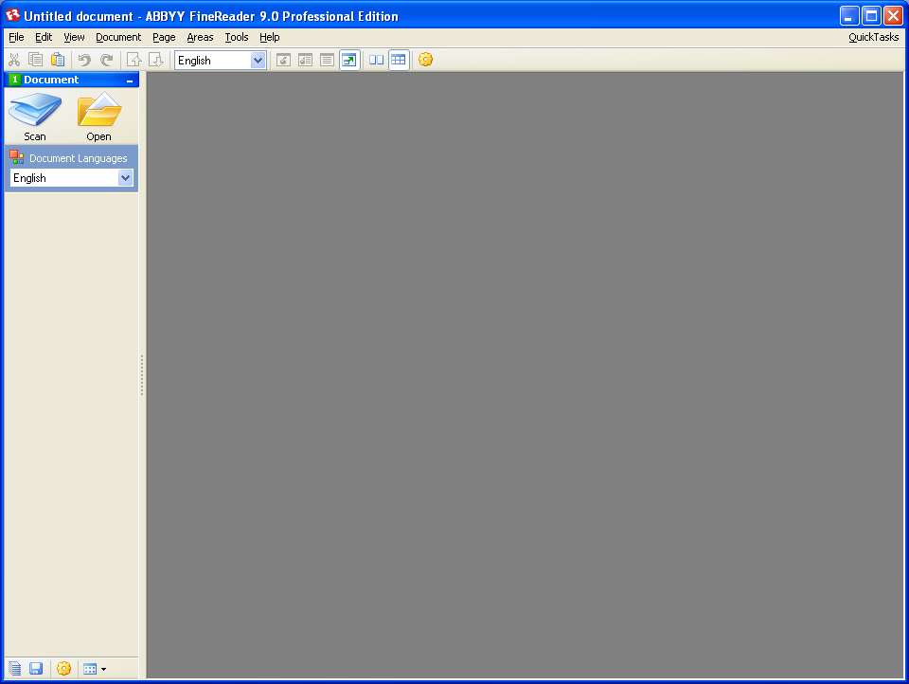

Toolbar Set-up
Go to View > Toolbars. Turn on the Quick Access Toolbar.

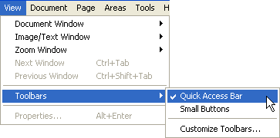

Options Set-up
In the menus, go to Tools > Options or use the keyboard shortcut CTRL + Shift + O.

Document Tab
Under the Document tab, you can choose the languages that are in your document. Click the Edit Languages button to access mathematical and scientific options.

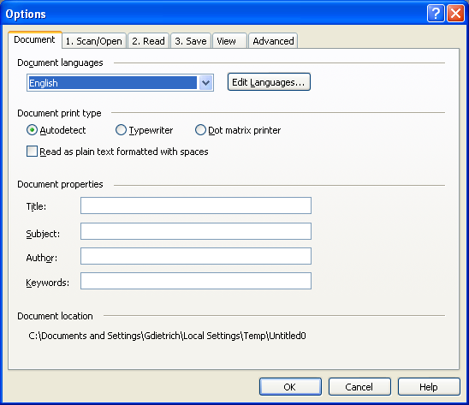

The more precise you can be about which languages are in a document, the better your recognition will be. Remember to turn on “Greek” whenever you are processing math so that you are able to OCR the Greek letters (like pi) that are used as mathematical symbols.
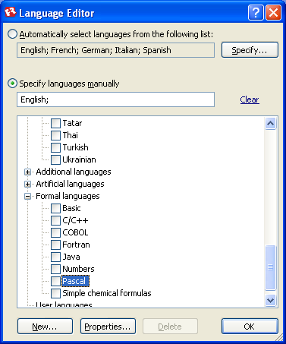

1. Scan/Open Tab
Make sure that “Do not read and analyze” is unchecked. You want to be able to control what FineReader does, not have it start automatically.

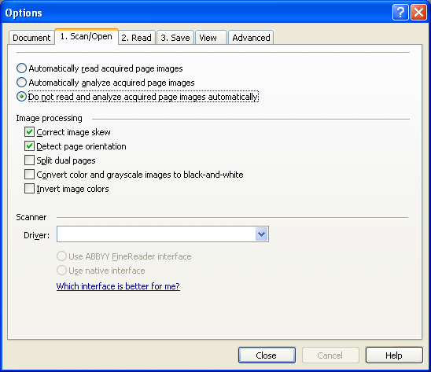

2. Read Tab
Under the Read tab, you can choose the reading mode (Thorough) and opt to train the patterns of unusual fonts.

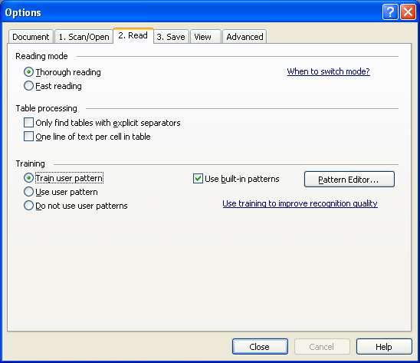

FineReader now behaves much more like OmniPage with its ability to train recognition of unusual fonts. In order to use this feature, make sure that “Train user pattern” is selected. To load an already established pattern, select “Use user pattern.” Below are the instructions from the FineReader help menu.

- Select Tools > Options… and click the 2. Read tab.
- Select Train user pattern under Training.
- Click the Pattern Editor… button.
- In the Pattern Editor dialog box, click New….
- In the Create Pattern dialog box, type in a name for your new pattern and click OK.
- Close the Pattern Editor and the Options dialog boxes by clicking the Close button in each.
- On the toolbar at the top of the Image window, click Read.
- Now if ABBYY FineReader encounters an unknown character, a Pattern Training dialog box will display the unknown character.
- Teach new characters and ligatures.
- A ligature is a combination of two or three "glued" characters (for example, fi, fl, ffi, etc.). These characters are difficult to separate because they are "glued" during printing. In fact, better results can be obtained by treating them as single compound characters.
Note: Words printed in bold or italic type in your text or words in superscript/subscript may be retained in the recognized text by selecting the corresponding options under Effects.
To go back to a previously trained character, click the Back button. The frame will jump to its previous location and the latest trained "character image-keyboard character" correspondence will be removed from the pattern. The Back button will function only within one word.

Important!
- You can only train the system to read the characters included in the alphabet of the recognition language. To train ABBYY FineReader to read characters that cannot be entered from the keyboard, use a combination of two characters to denote these non-existent characters or copy the desired character from the Insert Character dialog box (click to open the dialog box).
- Each pattern may contain up to 1,000 new characters. However, avoid creating too many ligatures, as this may adversely affect OCR quality.

3. Save Tab
Under the Save Tab, you can access settings for particular formats.

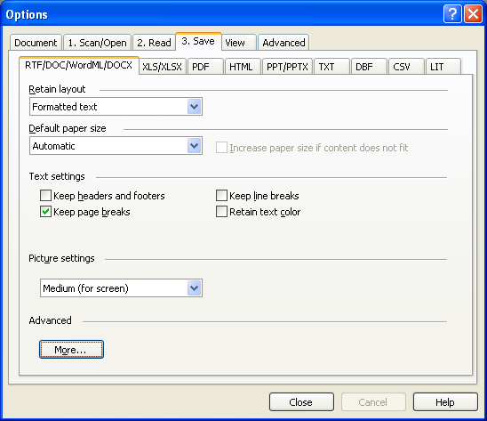

You can set the options for how FineReader will save documents into different formats. For Microsoft Word, you can retain the page breaks, if you wish. Please note that it is generally best to use Formatted text for the layout, rather than Exact Copy or Editable Copy, which may result in text boxes.

View Tab
Under the View tab, you can now choose whether to see thumbnails or details in the document window. For those using screen readers, I would recommend using the Details panel.

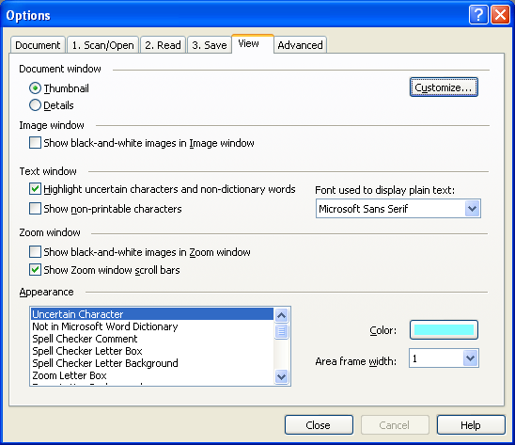

Both views can be adjusted to include exactly the information that you want to show. Click the Customize button.

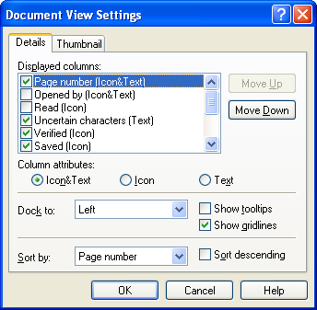

Note that in the combo box at the bottom of the page, you can choose which colors to use for highlighting uncertain characters, non-dictionary words, etc.

Advanced Tab
The Advanced table has a couple of checkboxes to watch out for. In general, you do not want to look for barcodes, nor do you want to open the last FineReader document at startup.

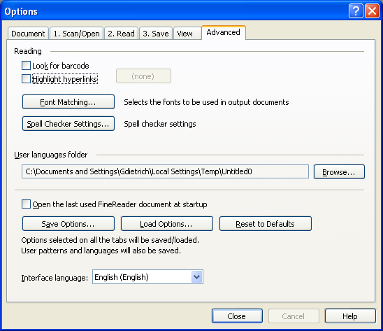

Spell Checker Settings
Under the Spell Checker Settings button, you can uncheck the "Stop at words not found in dictionary" option if you will be spell checking anyway later in Word. If you will not be taking the document into Word, then go ahead and turn on the dictionary. Note that if FineReader is not quite getting the spacing around punctuation correct, you can adjust the setting in this window.

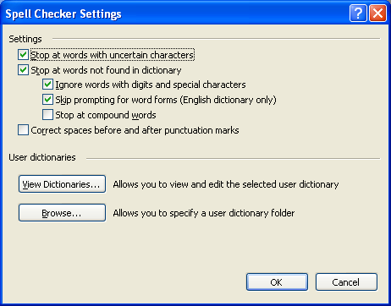

You can also choose specialized dictionaries in this tab by selecting the View Dictionaries button. Note that if you are running OCR on a science text related to medicine, biology, or chemistry, it is good to turn on the English Medical Terminology. Similarly, if you are working on a business or legal text, you may receive better results by loading the English Legal Terminology.

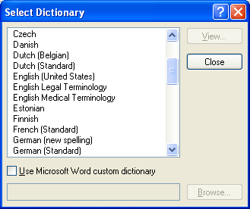

Customize Toolbars
Choose View > Customize Toolbars. Move the renumber pages icon onto the Quick Access Toolbar.

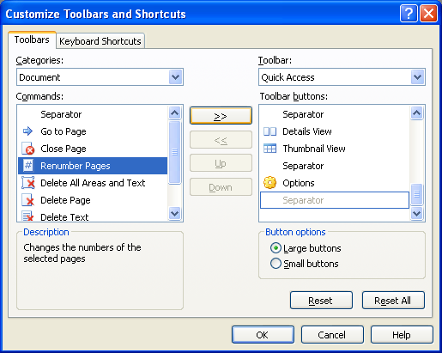

Processing an Image (TIFF or PDF) File

Step One: Open an Image File or a PDF File
Click on the Open icon or use File > Open or use the keyboard shortcut Ctrl + O.

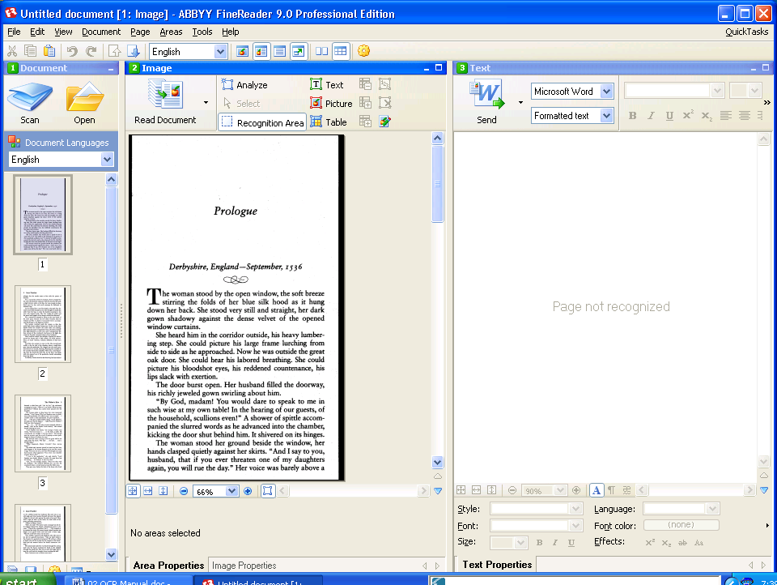

Step Two: Analyze Layout
Use the Analyze Layout option (Document > Analyze Layout or Ctrl + Shift + E) first on complex layouts then read the pages. This workflow reduces the chance of the program crashing and allows layout adjustment without running OCR more than once..

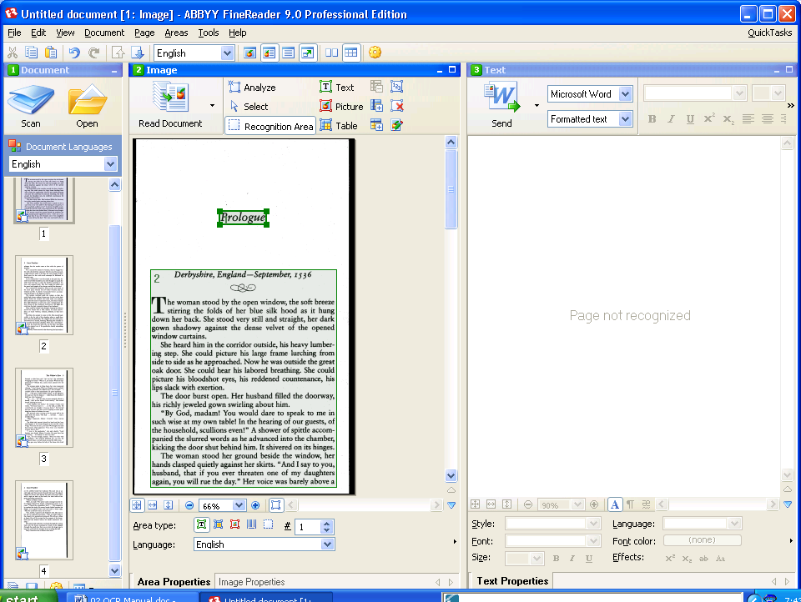

Step Three: Adjust Areas
Use the tools to add to or delete areas (formerly called blocks). To reorder zones, right click and turn on the Area Properties. It will display at the bottom of the image window. To change the reading order, simply change the number after the # sign.

Tip: To see more of the page, turn off the Area Properties by right-clicking on the image and deselecting “Area Properties.”

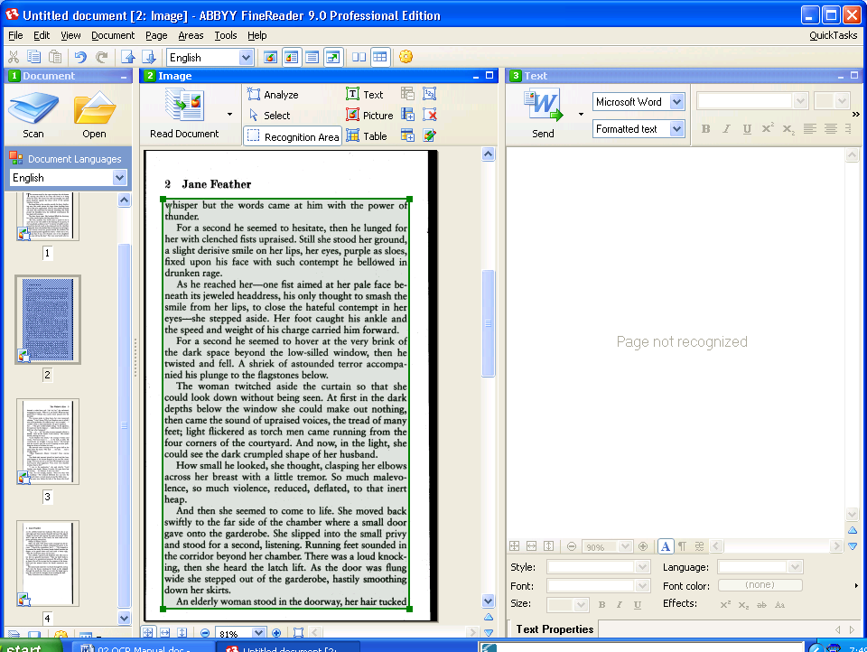

Step Four: Read Document
Go to Document > Read Document or use the keyboard shortcut Ctrl + Shift + R.

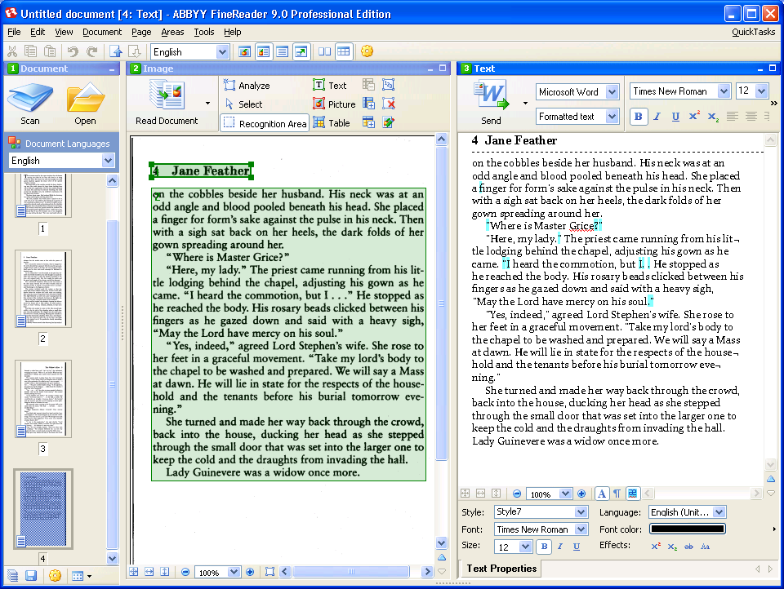

Step Five: Check Spelling
Go to Tools > Check Spelling. If you wish to change the settings for the spell checker, you can click on “Options.”
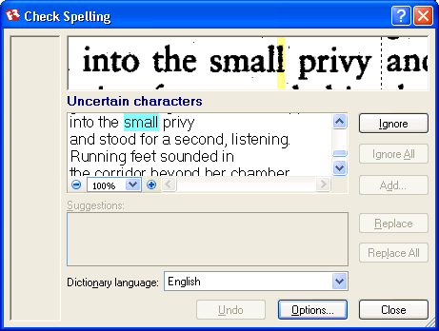

Step Six: Save the Document
File > Save As > Microsoft Word Document

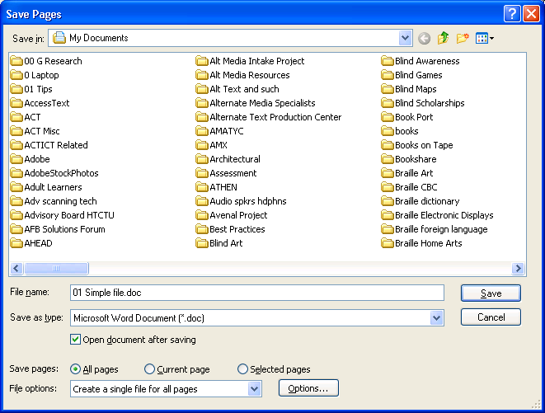

Note that you can adjust your settings for a specific format by clicking on “Options.” To avoid text boxes, save the layout as “Formatted Text.”

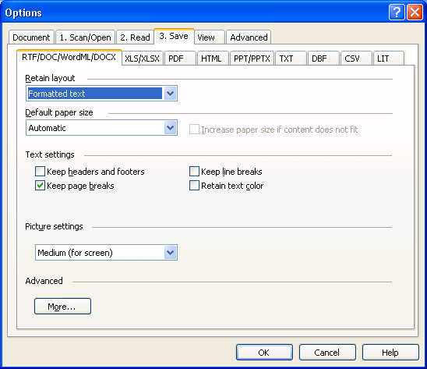

FineReader Tips
Zoom window: FineReader has a zoom window (View > Zoom Window) that allows you to enlarge selected areas of the image or text.
Stop spell check: To tell the program just to find OCR errors and not unknown words, go to Tools > Options > Check Spelling. Uncheck "Stop at words not found in dictionary.".
Document, Page, or Area: Controls are now broken out under menu choices based on the size of the overall section that you want to work on. To apply a command to the entire document, look under Document on the menu bar. When you wish to work on an individual page, look under Page, etc.
Eraser: The eraser tool allows you to edit the underlying TIFF file by deleting pixels (i.e., changing black to white). If you wish to save the changes, go under File to Save Images.

The eraser tool is now located under Page > Edit Page Image or use the shortcut keys Ctrl + Shift + C. The image for the page you are on will open in a new window titled Edit Page Image.

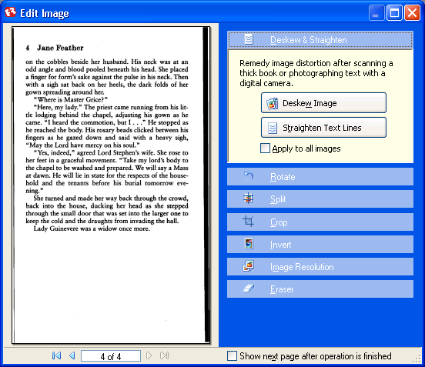

Automating Tasks
You can now set up workflows in Abbyy FineReader.

Creating an Automated Task
As an example, we will create a workflow to OCR TIFF files that are in a folder and then save the files as a FineReader file. All files will be saved in one FineReader batch.
- Start the Automation Manager (select Tools>Automated Task>Automation Manager).

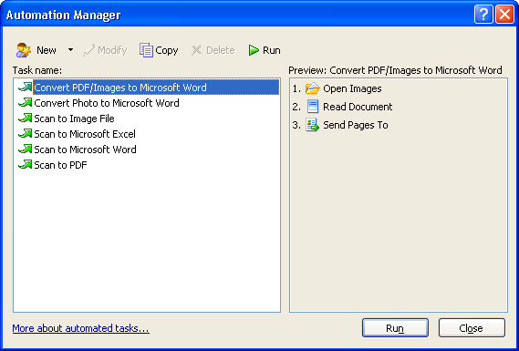

- In the Automation Manager dialog box, click the New button on the toolbar.

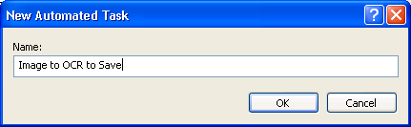

- In the Automation Wizard dialog box, click the desired step from the list of steps in the left-hand pane. The selected step will be displayed in the right-hand pane.
- Click Change… to change the properties of the step

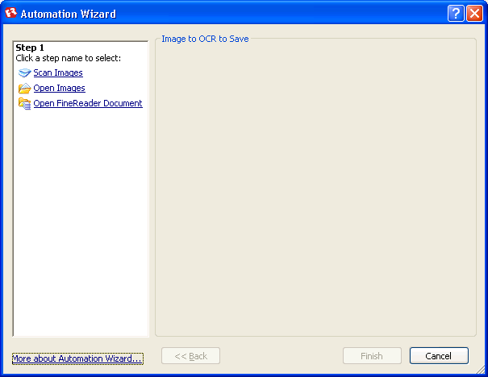

To find the folder containing the files you wish to process, click on Change and then Browse.

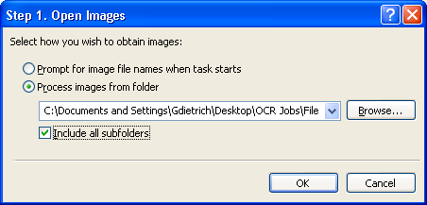

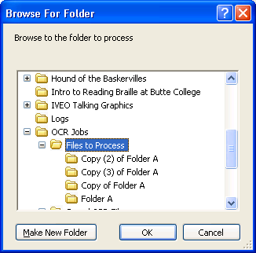

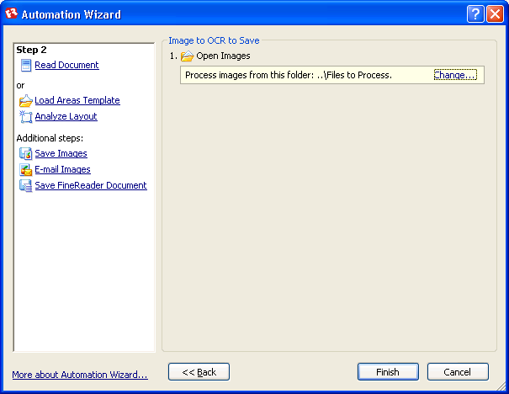

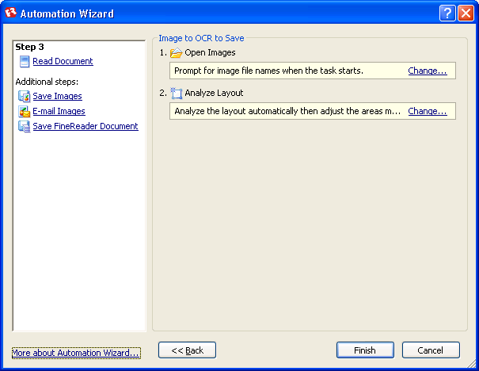

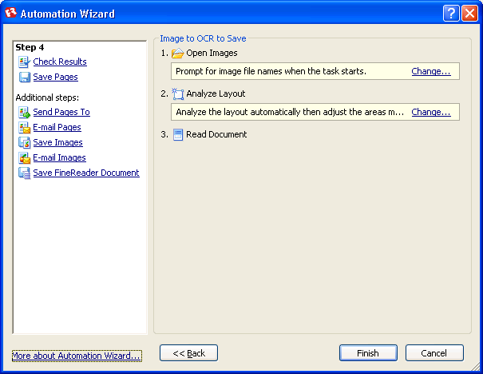

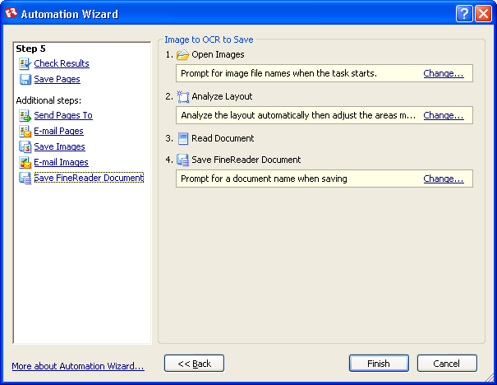

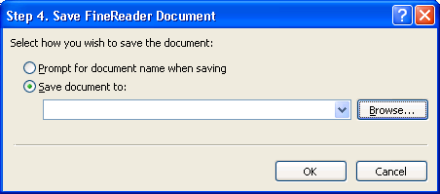

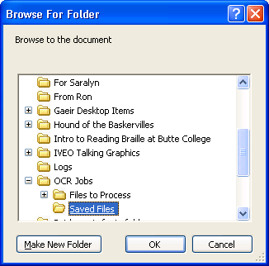

- Once you have added all the necessary steps to your automated task and selected their properties, click Finish.

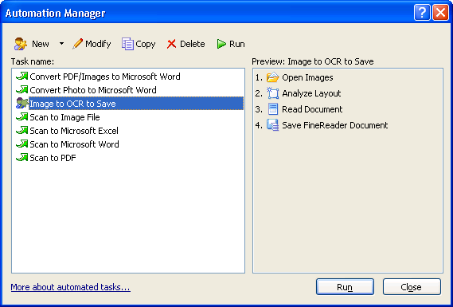

OmniPage Pro
Nuance
1 Wayside Road
Burlington, MA 01803
781-565-5000
www.nuance.com

Interface
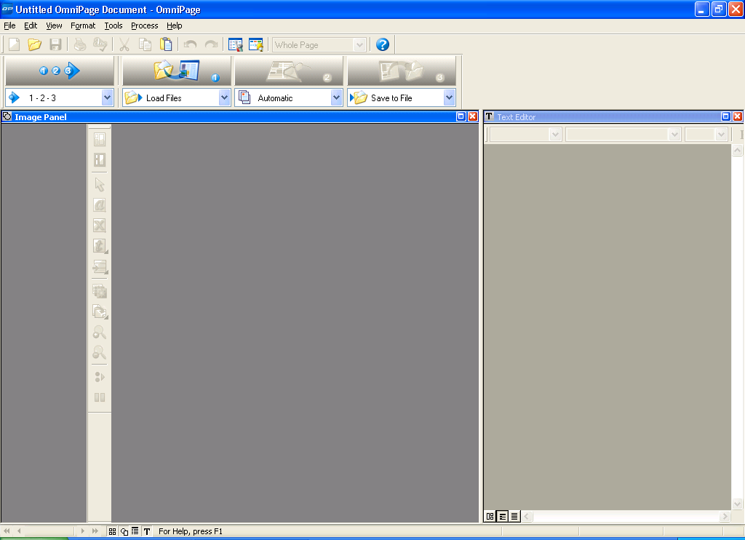

Document Manager
Of the two OCR programs, OmniPage is the more accessible for someone who is blind, and the main reason for that is the document manager. As a sighted-user, I generally prefer to work with it off, since I do not want to allot the screen space to it. For a quick check to see exactly where the program is in the OCR process, however, it can be very useful.

Alt V + N will toggle the document manager on and off. It appears at the bottom of the window, and the area can be modified by dragging the horizontal bar at the top of the pane.

The document manager is completely accessible with screen readers (JAWS, Window-Eyes, SuperNova, etc.) and will give you a lot of information about your OmniPage document. You will need to configure it, however, or else it will provide a lot of confusing, extraneous information.

Configuration for Blind User
The directions below are written to be usable by someone who is blind or sighted.

OmniPage includes four possible views:
1. The thumbnail images: This view shows thumbnails for each page and allows easy mouse navigation from one page to another. Once in this pane, you can also navigate with the arrow keys.
2. The page image: This is the original image of the document. Both the page image and thumbnail image are part of the “Image Panel.” This panel is optional for a blind user.
3. The text editor: This view shows the text after OCR has been run.
4. The document manager: This view provides a great deal of information about the document, and it is fully accessible to screen readers and refreshable Braille displays.

All of these views can be turned on and off under the View (Alt + V) menu on the menu bar. Please note that the F6 key will move you from one pane to the next.

To configure the document manager, you need to go under the View menu to Customize Columns ( Alt V + C).

The default at the beginning is to have all the columns on. This is not helpful; in fact, some of them show icons, which is totally useless for someone who is blind.

I recommend just using the first five columns on the list:
Status
Characters
Suspect words
Reject characters
Words

If the screen reader does not immediately start reading the choices in the choice box, Alt + C should move the focus to that window. These are check boxes, so you can use your space bar to select and deselect.

Mostly, you will want to deselect. Leave the first five selected then go through the list and deselect the rest. The down arrow key will move you properly from one to the other.

A minor point, but once you have deselected the rest of the long list, you might want to use your up arrow (just hold it down until you hear “Status”) to go back to the top of the list. The columns are set too narrow for a sighted person to read the column labels, and I do not know whether every screen reader will read them configured like that or not.

You can reset the sizes as follows:
With the cursor on the column name (for instance, Status is the first column name), go to the Column Width edit box (Alt + W). Type in 100 (the unit is pixels). Alt + C will move you back to the column list and you can arrow down to the next column name and repeat the process.

If you are using a Braille display, you may want to play with the column sizes a bit more to get a precise fit. The 100 pixel width is just a rule of thumb. For a more precise fit, try starting with these settings:
Status: 67 pixels
Characters: 68 pixels
Reject Characters: 103 pixels
Words: 48 pixels
Suspect Words: 87 pixels

One more refinement. I would recommend going to the “Reject Characters” choice and move it up (Alt + U). Now arrow down to the “Words” choice and again move it up (Alt + U). This order change allows you to hear total characters followed by suspect ones and then total words followed by suspect words, which gives you a sense of how well-recognized the page was. Too many errors, and you may need a better scan.

Make sure to say OK when all of this is done. OmniPage will remember the settings, so you should only need to do all this once.

If your focus is not in the Document Manager pane, use the F6 key to navigate to the proper pane.

As the screen reader reads across the row in the document manager, you will hear the page number where your focus is, then the status, then the characters on the page, the number of rejected characters, the number of words on the page, and the number of suspect words.

You can use the arrow keys to move from page to page.

You may find that you need even fewer columns than I’ve suggested, but these five are a nice starting point for you to experiment with.

As an example of one way to use the document manager, you may have recognized (i.e., run OCR) on a portion of the document and then stopped. At a later time, you want to resume processing the document.

To find out where you left off, you would move down the list until you find a page that has not been recognized. It will say acquired (meaning that the image file is present but OCR has not yet been run).

Starting at the first one that says “Acquired,” hold down your shift key and use your down arrow until you have selected all the pages in the document.

Once the pages have been selected, use Control + 2 to run the OCR.

I like to run the OCR separate from the proofreading, as I believe that combining the two leads to more crashing.

If the two are still linked, that is, if the proofreading window opens while the OCR is still running, then change your options. Go to Tools and Options: Alt T + O. In the Options window, go to the Proofing tab. Uncheck the second checkbox on the list, “Automatically proofread results after OCR.” Then say OK.

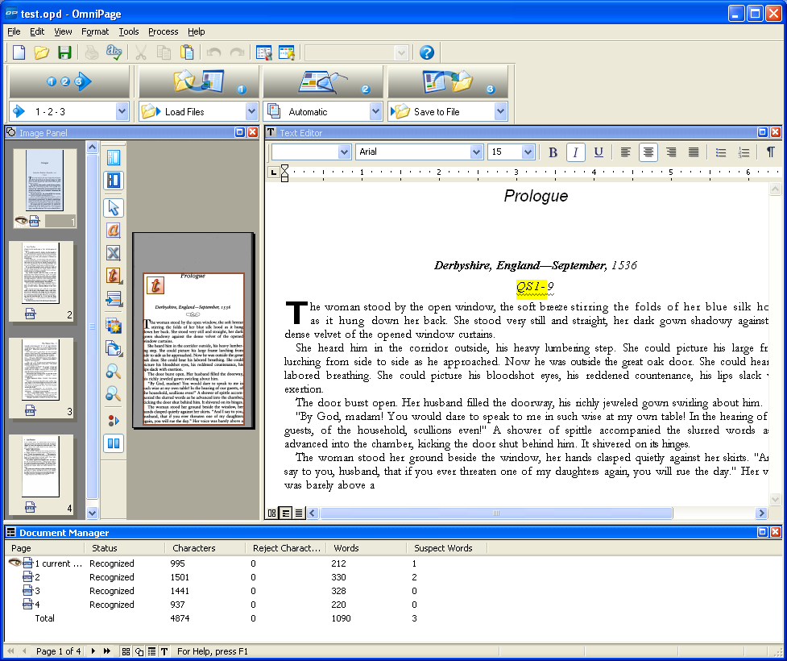

Toolbars
To help you become accustomed to using the shortcut keys, turn on the shortcut keys on the toolbars: View > Toolbars. Check the With Shortcut Keys checkboxes.

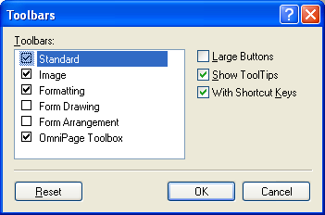

Options Set-up
In the menus, go to Tools > Options or use the keyboard shortcut Alt + T + O.

OCR Tab
The OCR tab allows you to select the languages that are included in a document. If you are working on a foreign language document, you can choose English, as well as the foreign language. Choosing a foreign language allows the program to recognize that letters in that language that use diacritical marks (umlauts, cedillas, accents, etc.). If you are processing a math book, turn on Greek so that the Greek letters (alpha, pi, theta, etc.) used in mathematics will be recognized. Be sure that you only select the languages that you need, however, as the program will look for (and find!) the letters used in those languages.

If you are processing a document that has a great deal of financial, legal, or medical terminology, be sure to turn on the professional dictionary for that subject. Please note that you can also load custom dictionaries if there is a great deal of unusual vocabulary.

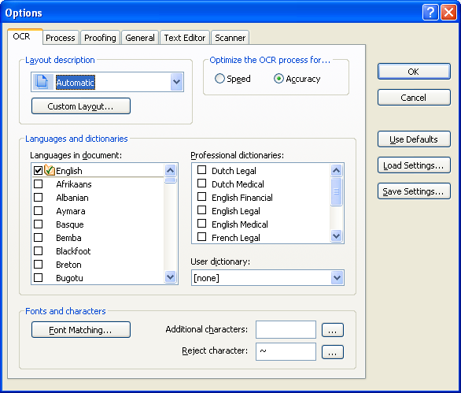

Process Tab
The OCR tab allows you to specify where to add pages to the OmniPage document if you have somehow skipped a page during scanning or need to add a page that needed to be rescanned. Make a TIFF file of the page to add and then set the option in this window prior to inserting it. Note that you can set the option to “before current page” if you need to insert a page in the middle of the document.

Make sure to set the “Page rotation” option to “None.” You can manually rotate a page if you need to, and the program does not do a good job of analyzing orientation.

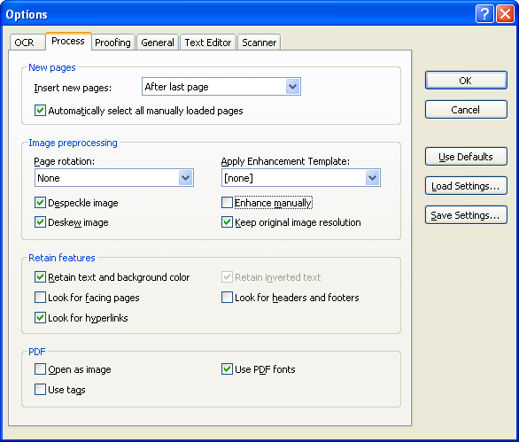

Proofing Tab
Depending on whether or not you will run a spell check later during your workflow, you may check or uncheck the “Mark all non-dictionary words” option. If you will be running a spell check in MS Word, you can leave this uncheck.

Make sure to uncheck “Automatically proofread results after OCR.” You can launch the proofreading window automatically, and there are other methods for proofreading your document that you may prefer using.

If you wish to use the IntelliTrain feature, you will need to use the proofreading window. IntelliTrain remembers the corrections that you have made and looks for patterns that the program can apply to better recognize unusual fonts. It makes most sense to use IntelliTrain if you are processing a book in sections. You can load the IntelliTrain data from a previous section before processing the next one, ensuring better recognition. If you use this feature, check the box to prompt to save. If you are not using the feature, then uncheck that box.

You can load IntelliTrain data from a previous file by selecting the three-dot browse button.
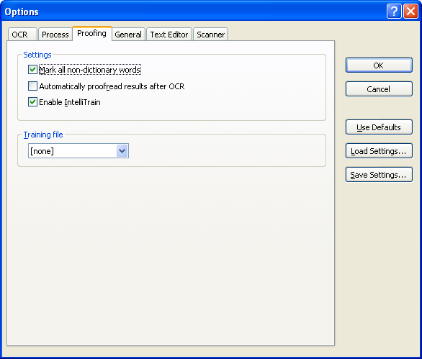

General Tab
There are a number of useful features on this tab, depending on how you use your program. You can add OmniPage to your system tray for quick access. You can enable update detection to make sure that you always have the latest versions. We will not be using any of the features in this tab for this class.

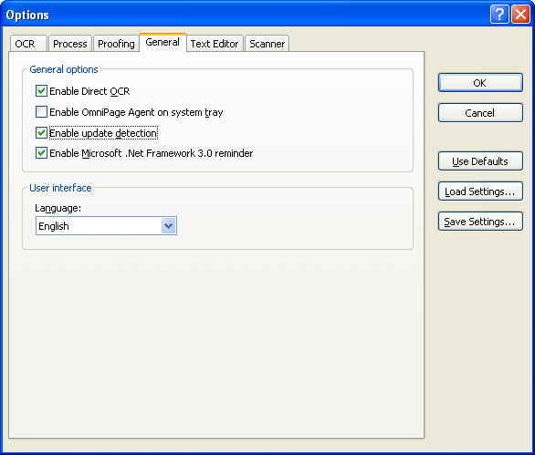

Text Editor Tab
Under Show, mark sure that “Headers and Footers” is unchecked. Otherwise, OmniPage will attempt to automatically detect these features, and you cannot easily access them—either to include the page number or to reorder the zone. It also will not include the header or footer when you save out to Word, which means that page numbers will be lost.

Make sure to check “Reading Order.” If this feature is not checked, you will not see the reader order of the zones (i.e., which zone comes before which other zone) or reorder them.

If your text in the text editor pane ever looks funny (running off the screen), check to make sure that “Wrap to Ruler” is turned on. Having it on is the default, so this should not be an issue.

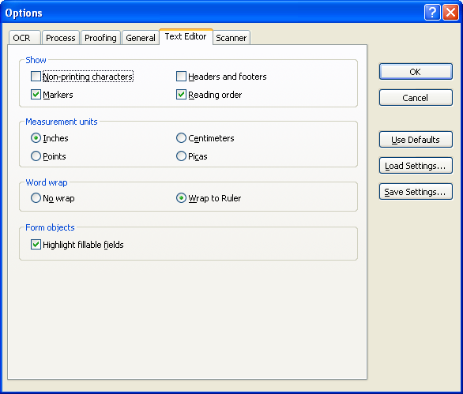

Scanner Tab
We do not generally recommend using OmniPage for scanning; however, if you need to do a great deal of color scanning, you might wish to use if. If you do use OmniPage for scanning, make sure to install the actual scanning program for your scanner in OmniPage. You can embed the drivers that came with your scanner in the OCR program. Do not use the generic drivers that came with OmniPage. Even using this technique, you may find a loss of speed and features scanning through OmniPage. Unless you have a compelling reason to scan through this program, stick with using the scanning utility that comes with your high speed scanner.
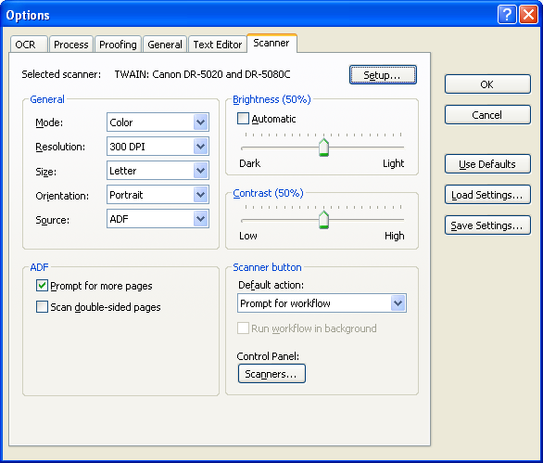

Processing an Image (TIFF or PDF) File

Step One: Load a File
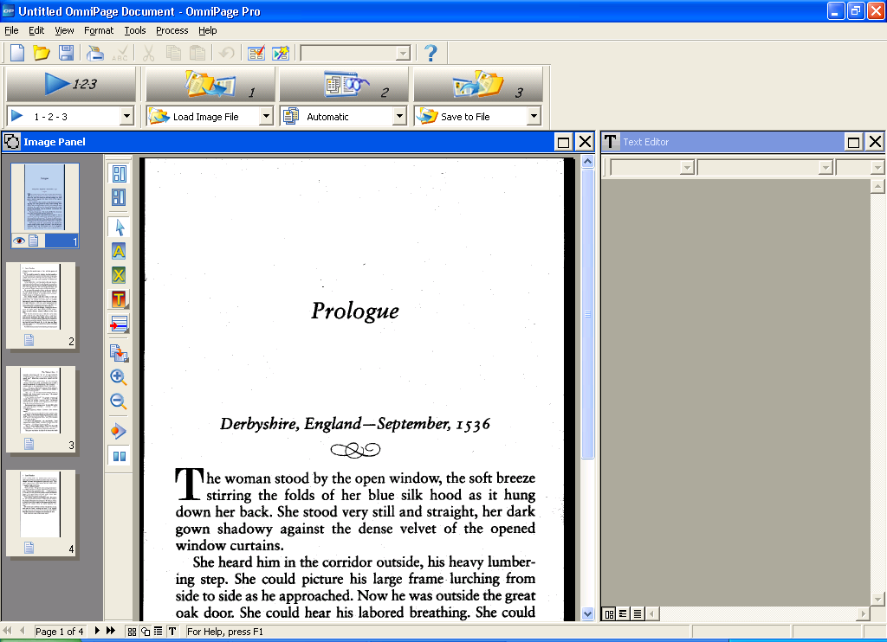

Step Two: Run the OCR
Be sure to select the pages before running the OCR. Click on the first thumbnail and use CTRL + A to select all.
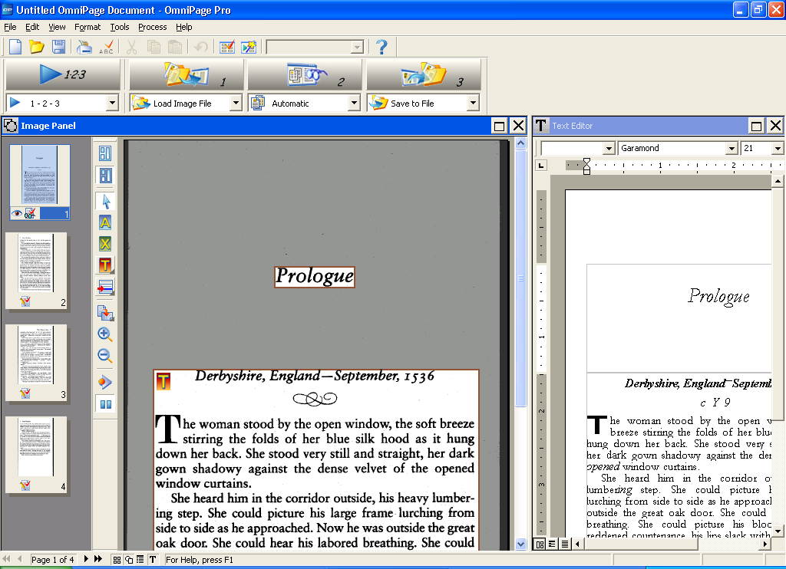

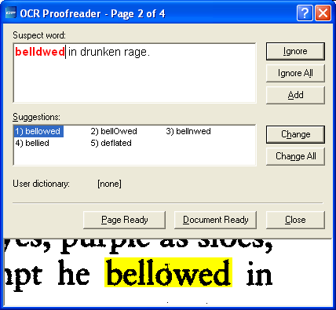

Step Three: Adjust Zones
Use the "on-the-fly" tool to redraw zones.
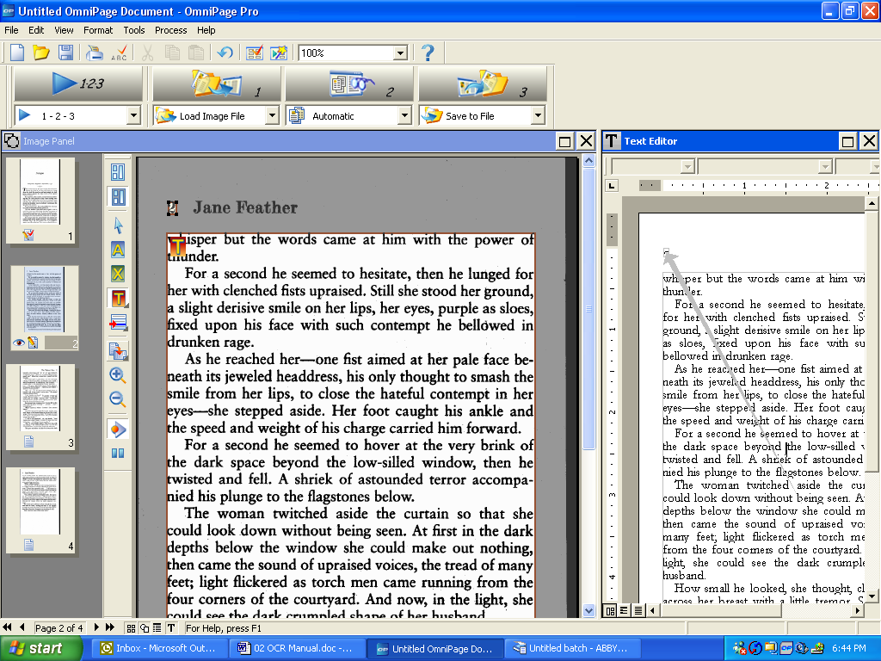

To reorder zones, right click in Text Editor view and change reading order. You may need to ungroup the zones first. Right click and choose ungroup.

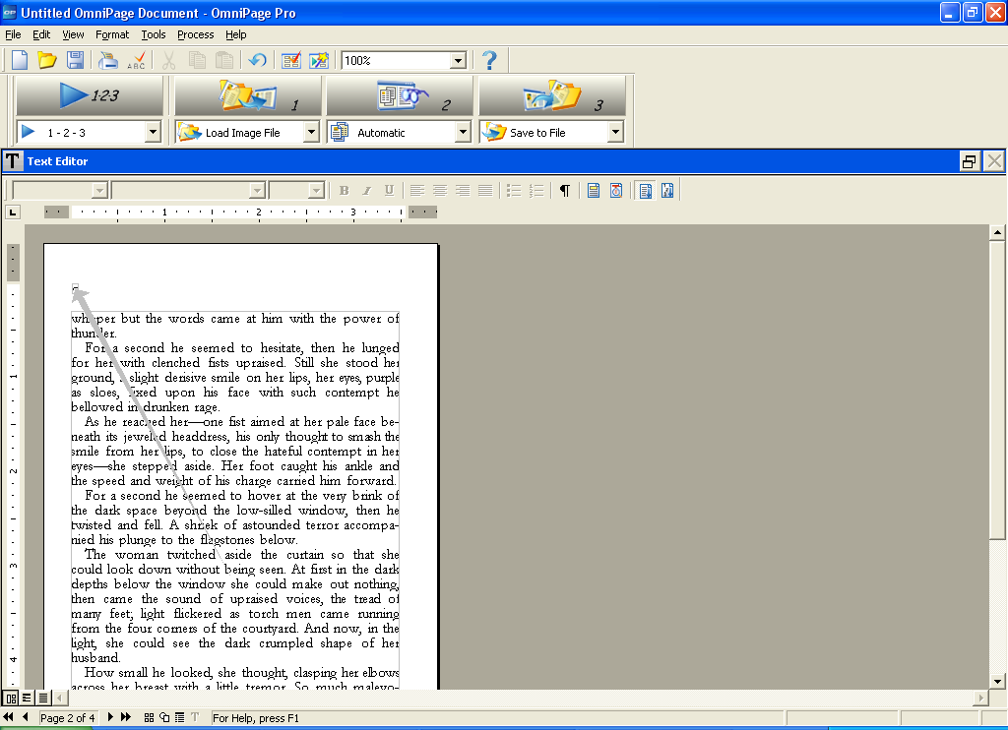

Next right click and choose, “Change Reading Order.” You will now see numbers showing the order of the zones.

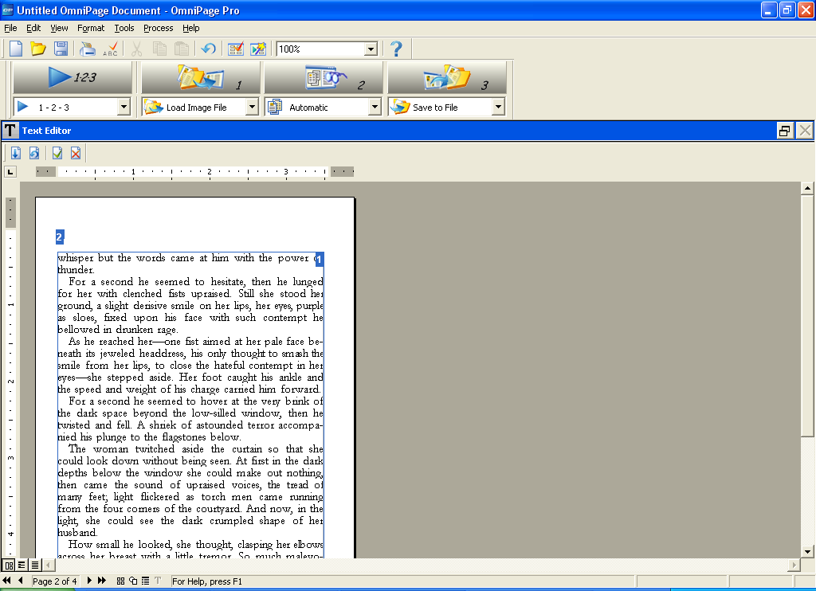

Right click again and choose “Define Reading Order.” Your numbers will now disappear, and you can click on the zones in the order that you wish to have them read. When you are satisfied with the order, right click one last time and select “Apply Order.”

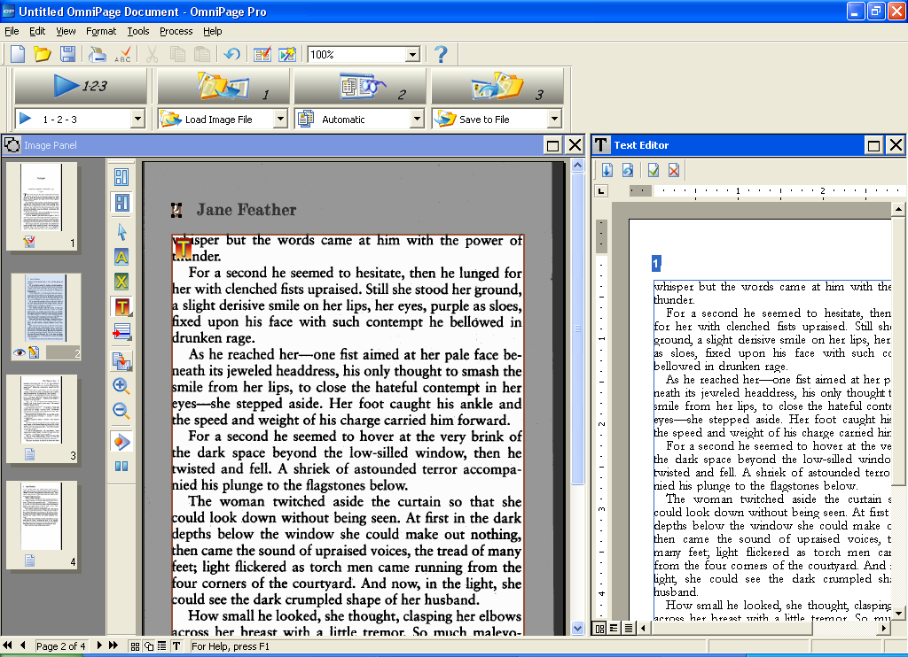

Step Four: Save the Document
Make sure to set the view for your text editor to “Formatted Text View” before you save. The setting is under View > Text Editor Views or the buttons at the bottom left of the text editor pane.

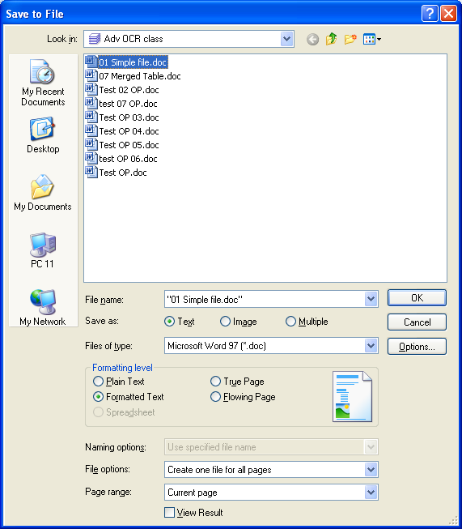

When you save the document, you have a number of options. You can save the text in MS Word or other text formats. You can save the document as a graphical PDF or a TIFF. You can also choose “save as multiple” and save to Word and PDF or Word and TIFF at the same time.

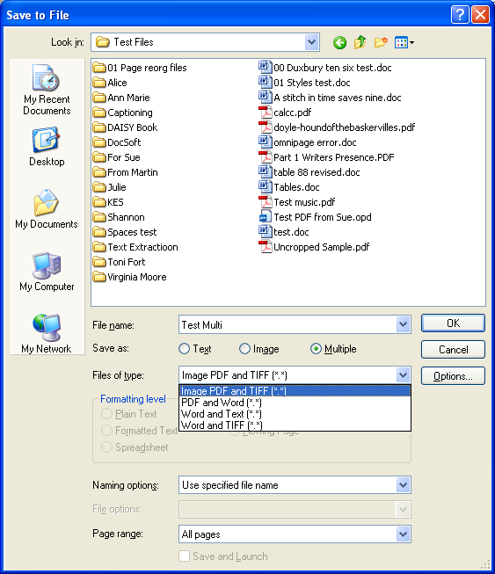

If you have a PDF document that you want to convert to TIFF, you can load the file into OmniPage and then jump directly to “save as” (step 3), without running the OCR. Since you are essentially going from one graphical format to another, there is no point to introducing possible recognition errors by running OCR. The only reason to run the OCR would be if you wanted to delete portions of the document before saving it to TIFF.

If you are saving to Word and you do not want any textboxes, you will need to remove the “retain drop cap” option. After selecting Microsoft Word as the file type to save, click on the “Options” button. Scroll down until you see the “Retain drop caps” checkbox and uncheck it. Note that you can check the “Make changes permanent” button if you want to change the default.

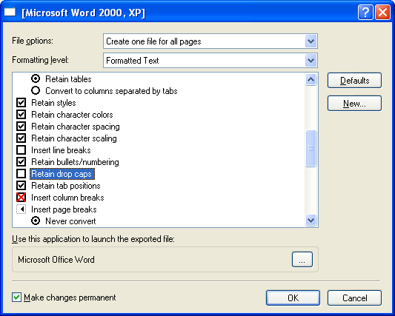

Also note that you have a choice of saving the entire OmniPage file to one document, saving individual pages as separate documents, and other variations.

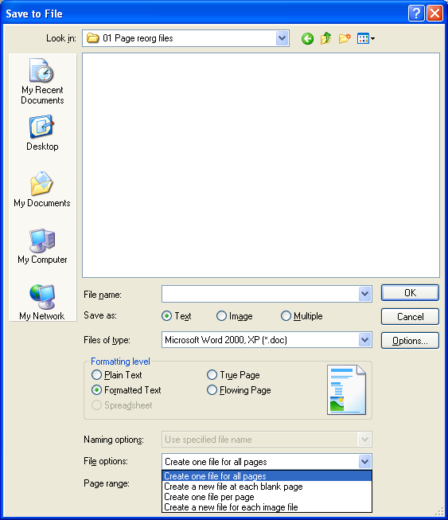

OmniPage Tips
Shortcut: To see the shortcut keys associated with menu items, go to View > Toolbars and check "with shortcut keys."
On-the-fly zoning: You can now modify zones without having to reimage the entire page. For small changes, click on the "on the fly" button.
Stop spell check: To tell the program just to find OCR errors and not unknown words, go to Tools > Options > Proofing and uncheck "Mark non-dictionary words."
Reordering zones: You can reorder the zones in the text editor window; however, it must be set to True Page view (View > Text Editor Views > True Page). If the zones are locked, right click and choose the "ungroup" option. Then choose "change reading order" and "define reading order."
Verifier: A zoom window, called the verifier, is included in the text editor view. Click on show/hide verifier or use F9 while in the text editor window.
Saving: Note that you can save one document as individual pages, save multiple documents into one, or save each image as one document. Be aware of which you choose.
Formats: For PDF, use True Page. For Word, use Flowing Page or Retain Fonts and Paragraphs.
Batch manager: The batch manager is the new scheduler for running OCR, converting documents, etc. Note that you can also cancel a scheduled job through the batch manager.
Templates: For books with a standard layout, you can create a template specifically for that book.
Speech: OmniPage will read text to speech as well as responding to verbal commands in some of the windows.

