Accessibility concern with the Virtual Classroom collaboration tool

After the virtual classroom tool is launched from the Blackboard LMS, there is a link to an accessible version of the tool:

Accessible virtual classroom link
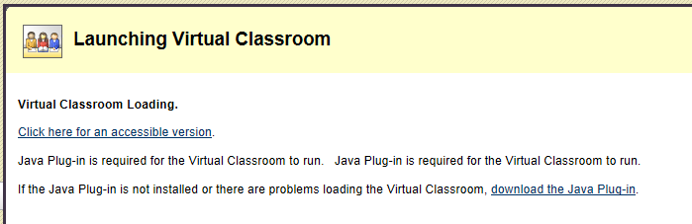

This accessible version of the tool is inaccessible with the JAWS screen reader.

I followed the instructions, screenshot below, to install JAVA Access Bridge and still could not get JAWS to interact with the accessible virtual classroom interface.

JAVA Access Bridge installation instructions
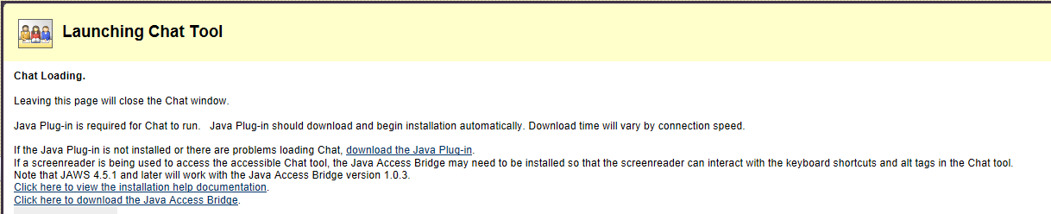

JAWS can tab through the buttons and text field, but JAWS is unaware of the names of the buttons. Also, JAWS cannot activate the buttons. Most importantly, JAWS does not have access to the message board and is not notified when posts are made.

I included a screenshot of the accessible virtual classroom interface for reference.

Accessible virtual classroom GUI
