Presented by AHEAD in collaboration with ATHEN
16th Annual Accessing Higher Ground
16th Annual Accessing Higher Ground
Accessible Media, Web and Technology Conference
November 4-8, 2013

Call for Proposals

Accessing Higher Ground
Accessible Media, Web & Technology Conference
November 4-8, 2013

Westin Hotel - Westminster, CO
(midway between Denver & Boulder)

2013 Theme:
Integrating Universal Design Content into University Curriculum

AHG & AHEAD invites speaker proposals for its 16th annual Accessing Higher Ground Conference.

The conference focuses on:
- the implementation and benefits of Assistive Technology and Accessible Media in the university, business & public setting;
- legal and policy issues, including ADA and 508 compliance;
- The creation of accessible media and information resources, including Web pages and library resources are a particular focus of the event.
Universal Design (UD) Track:
- In particular, proposals that address Universal Design for Education or incorporating UD content into curriculum are encouraged
RFP info:
- Obtain a presenter application form (available March 1) at the URL below.
- First round deadline: April 5. Second round rfp, if needed, will have a deadline of May 5.

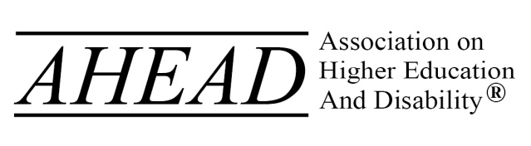
http://accessinghigherground.org
ahg@ahead.org * 303-492-8672

