ADA Compliance and Accessibility

ALEKS is sensitive to the fact that educational institutions are required to comply with Sections 504 and 508 of the Rehabilitation Act of 1973 and the Americans with Disabilities Act (ADA) of 1990. To facilitate such compliance, ALEKS strives to be inclusive in all our product offerings to the fullest extent possible and is committed to providing all students with the benefits of a complete ALEKS experience. We are continuing to evaluate accessibility technology to determine how it can be used to improve the ALEKS experience for disabled students.

ALEKS is accessible to many segments of the disabled population. Because there is no audio associated with the core ALEKS content, ALEKS is fully accessible to those who are partially or profoundly deaf. ALEKS does not rely exclusively on color to convey critical information so it is fully accessible to those that are color blind. Many students who have low vision or are otherwise visually impaired can use products such as Microsoft Magnifier to fully access ALEKS. Students who are incapable of using both a keyboard and a mouse simultaneously due to physical disabilities similarly have no limitations while using ALEKS. Profoundly blind students can access certain areas of ALEKS through the use of screen reader technology.

ALEKS Corporation has recently completed the process of reprograming all ALEKS Math courses from Java to JavaScript to make them more compatible with screen reader technology. To ensure that our accessibility efforts were as successful as possible, ALEKS worked with the Accessible Technology Initiative at The California State University to assist in design in accordance with W3C and WCAG 2.0 guidelines. Our JavaScript programming strategy incorporates WAI-ARIA to allow dynamic content and advanced user interface controls developed in JavaScript to interact more readily with screen readers.

In attempting to address the needs of students with limited vision and the needs of profoundly blind students, we have evaluated current screen reader technology and have determined it to be unsatisfactory in Math with regard to problems that are visually demanding. Within the JavaScript version of ALEKS Math content, we believe that input tools will be fully accessible.

Given the current state of assistive technology, many colleges and universities that have addressed the issue of teaching mathematics to profoundly blind students have determined that an “alternative accessible arrangement” in the form of human assistance (qualified readers or transcribers to record answers) is the best accommodation for those students as they work through either a traditional math curriculum and textbook or as they work with ALEKS. This approach is also consistent with their approach to other visually demanding course work.

We recognize that educational institutions must provide accommodations or modifications that would permit disabled students to receive all the educational benefits provided by the ALEKS technology in an equally effective and equally integrated manner. We are committed to broadening the accessibility of ALEKS and continuing to evaluate accessibility technology to determine how it can be used to improve the ALEKS experience for disabled students.

Which ALEKS courses are ADA compatible?
The following ALEKS courses are ADA compatible in that a majority of the content in each course can be made accessible for blind persons using an assistive listening system (screen reader technology). The accessible content in these ALEKS courses can be made available at both the class level and individual student level in order to meet the specific needs of each implementation.

The ADA compatible content has been rewritten and coded in order to comply with screen reading technologies. An instructor can choose to use either the ADA compatible version of the ALEKS content, or the original version.

ALEKS Courses
Basic Math | NCCCS Dev Math Module 010
Pre-Algebra | NCCCS Dev Math Module 020
Pre-Algebra & Introductory Algebra | NCCCS Dev Math Module 030
Beginning Algebra | NCCCS Dev Math Module 040
Beginning & Intermediate Algebra Combined | NCCCS Dev Math Module 050
Intermediate Algebra | NCCCS Dev Math Module 060
FL Math 0018 | NCCCS Dev Math Module 070
FL Math 0028 | NCCCS Dev Math Module 080
FL Math 0022 | Prep for Beginning Algebra
NCCCS Dev Math Module 010 | Prep for Intermediate Algebra
NCCCS Dev Math Module 020 | Prep for College Algebra

How can an instructor make use of the ADA compatible ALEKS courses?
Setting up Accessibility at the ALEKS Class Level:
Setting accessibility at the class level will restrict the ALEKS curriculum of any of the courses listed on page 2 to only include the accessible topics so that all students in the class will only see ADA compatible content. This scenario is ideal for classes or academic centers that specifically cater to visually-impaired students.

An instructor can turn on this setting during the first step of the Course Set-Up Wizard when they build a class. For existing classes, select Edit Course to update the setting.

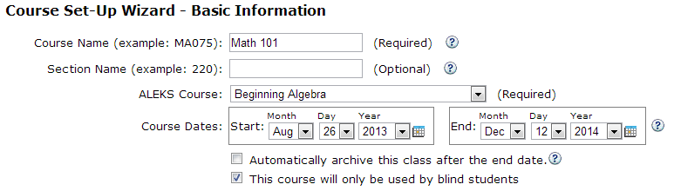

When accessibility is set at the class level, instructors will only see the ADA compliant curriculum in the Course Content Editor. Topics that are not ADA compliant yet will be excluded from the content.

Students also will only have the ADA compliant curriculum and the interface will slightly change so that they can make use of screen-reading technologies. The interface changes include:
- ADA compatible versions of the accessible topics so that they can properly use screen readers
- ALEKS Dictionary, Course Calendar, and Calculator are not available
- Topics that are not accessible yet in ALEKS are not included in the pie

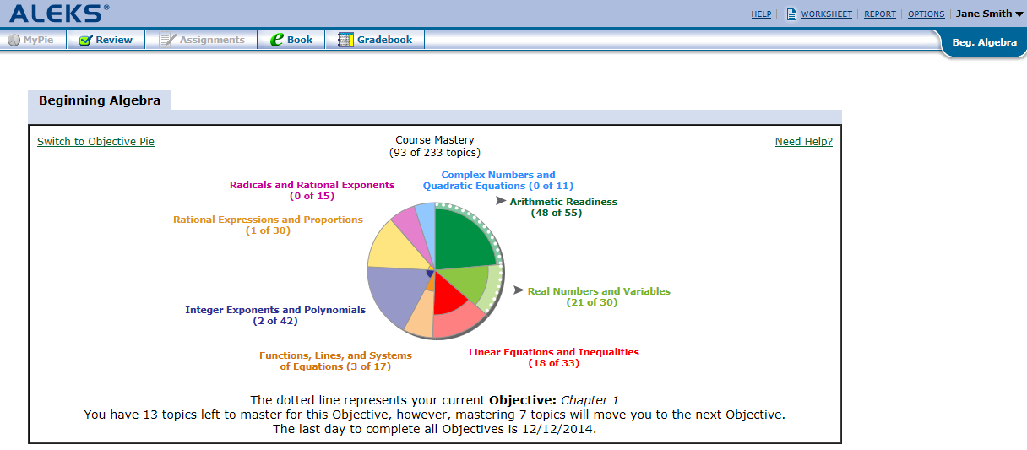

Setting up Accessibility at the Individual Student Level:
Setting accessibility at the individual student level will turn on the ADA compatible version of the ALEKS content of any of the courses listed on page 2 for those specific students. Other students in the class will have the full version of the ALEKS curriculum. This scenario is ideal for classes or academic centers that have a mix of students who are visually impaired and those who are not.

An instructor can turn on the setting at the individual student level by selecting the Edit Student link.

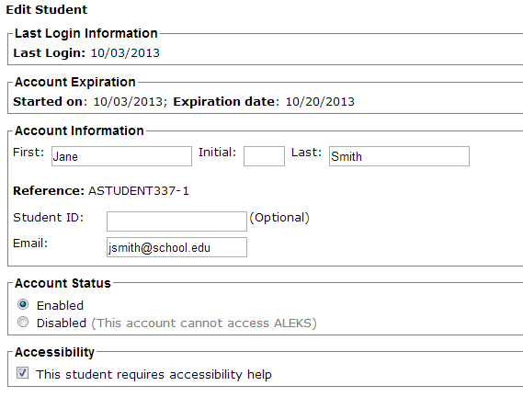
When accessibility is set for individual students, instructors will see the full ALEKS curriculum in the Course Content Editor and any accessible topics will be designated with an icon. From here, instructors can continue to customize the curriculum.
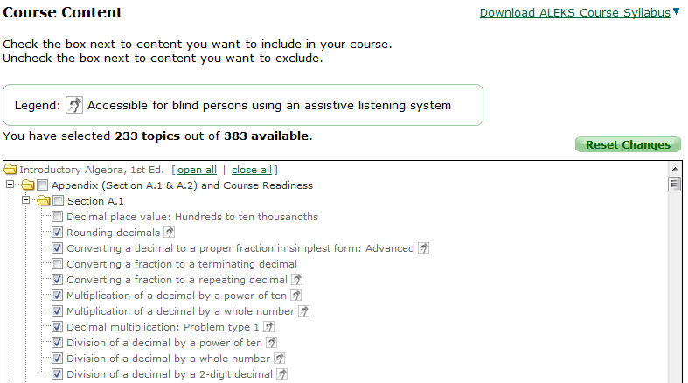
A student who has not been designated as needing accessibility help will see the standard version of the ALEKS curriculum and interface, including the ALEKS Calculator, Dictionary, and Course Calendar. For topics designated as accessible, these students will simply see the original version of the topic (i.e. not the ADA compatible version).

Students who have been designated as needing accessibility help will experience the following in ALEKS:
- ADA compatible versions of the accessible topics so that they can properly use screen readers
- ALEKS Dictionary, Course Calendar, and Calculator are not available
- Topics that have been included in the course by the instructor that are not accessible (i.e. they are not part of the ADA compliant content) will prompt the student that a human guide is needed to complete that topic.

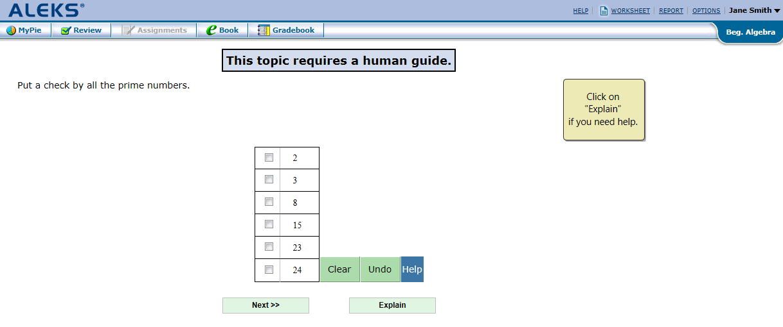
If an instructor does not want visually-impaired students to have any non-accessible topics in the pie (i.e. any topics that will prompt them for a human guide), the instructor should setup a separate ALEKS class for those students and turn on the accessibility setting at the class level.

For technical questions, please contact ALEKS Customer Support.
Email: http://support.aleks.com
Phone: (714) 619-7090

For strategies on implementation or use of ADA compliant ALEKS courses, please contact your Regional Marketing Manager at McGraw-Hill.

