Advanced Topics in Curricular Accessibility:
Strategies for Math and Science Accessibility

Sean Keegan,
Stanford University

Ron Stewart,
Chair AHEAD Instructional Materials Accessibility Group

Creative Commons License

Attribution - Non-Commercial - Share Alike
http://creativecommons.org/licenses/by-nc-sa/3.0/

MathType

Application Details
- URL: http://www.dessci.com/en/
- Cost: $97 ($57 Academic pricing)
- Operating Systems: Mac OS X 10.3 and later; Microsoft Windows XP, Vista, Windows 7

Introduction
MathType is an equation editor that allows for the rich display of mathematical numbers, symbols, and equations on the Microsoft Windows and Apple Macintosh platforms. MathType expands on the basic equation editor symbol set and provides additional equation and notation options for the display of mathematical content. MathType is commonly used within Microsoft Office applications (e.g., MS Word and PowerPoint) or the Apple iWork suite (e.g., Pages and Keynote), to author mathematical symbols and other science notation. In addition to desktop published applications, MathType can also support the inclusion of mathematical content into numerous Web-based platforms, including learning management systems, Google Docs, Wikipedia, and many other online interfaces. MathType is also a major component in supporting the conversion of documents into accessible alternate formats that include mathematical content.

MathType provides a separate editing interface for the authoring and editing of mathematical content. For applications like Microsoft Word or PowerPoint, math content may be created or edited in the MathType window and then saved back into the original document. This will create a MathType "object" in the document.

Adding Equations in Microsoft Word
Once MathType has been installed, an additional tab called the MathType ribbon will appear in the Microsoft Word interface. To add an equation to a document, switch to the MathType ribbon and select either the Inline Equation or Display Equation option. An Inline Equation will add a MathType object within the same line as the cursor focus. A Display Equation will add a MathType object centered and on a new line.

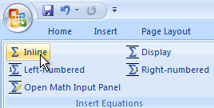

MathType will automatically open the MathType interface. For entering numbers or letters, use the keyboard to enter the relevant characters. MathType automatically adjusts the spacing and formatting for "math" specific content; as a result, the space bar is disabled to prevent unintended spacing in the equations.

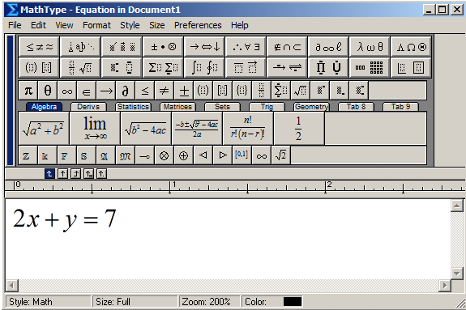

To save the equation back into the Microsoft Word document, choose File > Close and Return to Document (Ctrl+F4). This will save the current MathType object and return you back to the original document.

For entering symbols, such as the radical symbol or fraction symbol, use the templates provided just above the MathType editing window. These symbol templates provide a mechanism to control the placement of numbers or other characters in order to properly display the equation.

Example: Equations with Fractions
- To enter an equation with a fraction, use the fraction template to establish the numerator and denominator template regions (hotkey command Ctrl+F).
- Enter the appropriate value for either the numerator or denominator.
- Switch between the numerator and denominator regions by using the up or down arrow keys.
- To exit the numerator or denominator regions, press the right arrow key to move the cursor focus outside of the fraction.
- Return to the document by choosing File > Save and Close (Ctrl+F4).

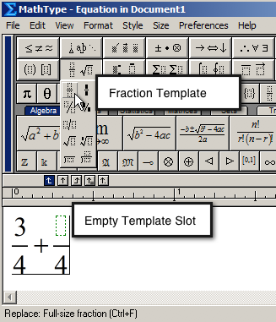

MathType Keyboard Commands
MathType provides a large number of keyboard commands to simplify the authoring or editing of mathematical symbols and equations. For instance, Ctrl+F will automatically include the fraction template whereas Ctrl+R will embed the square root symbol into the editing region.

To review all the keyboard commands or change the current keyboard mapping, in MathType go to Preferences > Customize Keyboard. Expand open the menu list of keyboard commands to review the currently established options or to set new keyboard commands.

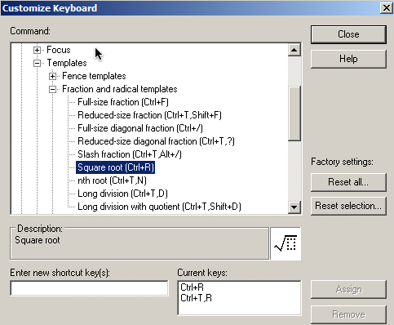

The current shortcut keys will be displayed in the "Current Keys" region. If you wish to return all the keyboard commands to the original settings, press the "Reset All" button. This will reset all the keyboard commands to the default settings when MathType was first installed.

Appearance of Math Content
One challenge when working with MathType is that it can be difficult to discern which parts of the document are text-based and which parts of the document are MathType objects. There are two methods one can use to differentiate between the text content and MathType objects.

Color
You can set MathType objects so that they may be a different color than the surrounding text-based information.

- To change the color of an equation, double-click on the equation to open the MathType window.
- Select the entire equation (Ctrl-A).
- Choose Format > Color, and then select the color you wish to use to represent the equations. The color you choose will be represented in the final version of the document, so ensure appropriate color contrast.
- To change all future equations to be of the same color, choose Format > Color > Edit Color Menu.
- Choose your desired color and press the Set as Default button. This will set the color for future MathType equations.

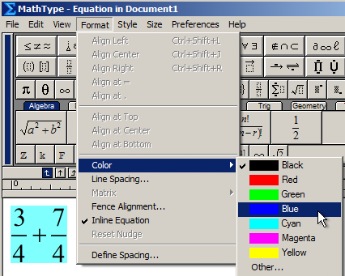

Browse by Equation
In addition to setting the color for a MathType equation, it is also possible to navigate through the document from equation to equation and skipping the text-based content. To move from equation to equation, press the Previous or Next button (in the Browse region) to move by MathType objects through the document.

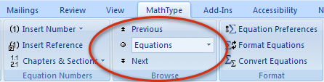

Browsing by equation will allow you to quickly jump from one equation to the next and provide a visual indicator of the equation in the document. This can be useful if you do not wish to change the color of equation as described in the previous section. This can also be a useful method to evaluate if there are any "empty" MathType objects in the document.

Export to the Web
MathType offers numerous export options for equations authored within the MathType interface. To ensure a version of the document is compatible with assistive technology, it is necessary to use the Publish to MathPage export option. Please note - this is different than using the Save As Web page option from within the Microsoft Office

Example: Exporting as a Web Page
- Create your document and add the relevant MathType objects.
- Save the document.
- Choose Export to MathPage in the MathType ribbon.

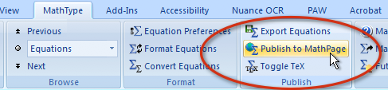

In the Publish to MathPage window, provide a title for the document. This will become the title of the Web page that is displayed at the top of the browser (this creates the <title> tag).

Check the location of where the file will be stored in the File Name region. To change the file save location, press the Browse button and select a new file location.

In the Equations section, click the radio button MathML using: and select the option "XHTML+MathML". This will create a Web page with MathML content compatible with the most Web browsers.

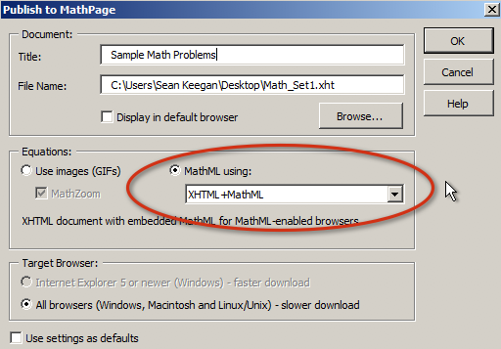

Open the resulting file using a MathML compatible Web browser (e.g., Internet Explorer with MathPlayer, Firefox, etc.). In order to view the resulting content in Internet Explorer, you will need to download and install the free MathPlayer plug-in from Design Science.

MathPlayer

Application Details
- URL: http://www.dessci.com/en/
- Cost: Free
- Operating Systems: For use with Internet Explorer (Microsoft Windows)

Introduction
MathPlayer is a free plug-in for the Internet Explorer browser that supports the rendering of MathML content for Web pages. In addition to the display of MathML content, MathPlayer provides a zoom function as well as the capability to speak and highlight the mathematical equations. MathPlayer also supports assistive computer technologies, such as screen-reading applications and MathML-DAISY books, by providing the necessary interface to read and highlight the math equation to the user.

Note - if you receive an error message that says Internet Explorer has blocked an Active X control when attempting to view MathML-content with MathPlayer, choose the Allow Blocked Content option to allow MathPlayer to start.

Math Zoom
To view a larger version of the math equation, use the Math Zoom function in MathPlayer. Perform a mouse-click on the equation and it will be displayed in a larger font with a yellow background.

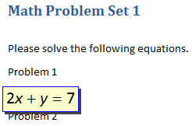

Speak Expression
MathPlayer can use the default speech engine and voice on the computer to speak and highlight the equation back to the user. Perform a right-click on the equation and choose Speak Expression. MathPlayer will use the current default speech engine to voice the math expression.

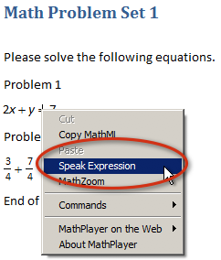

For individuals using assistive technologies, it is not necessary to perform a right-click and choose Speak Expression. When viewing the MathML content through a Web page, the assistive technology will automatically read the math equation content as well as the text on the page. The following assistive technologies are compatible with MathPlayer for MathML-based content.

Screen-Readers
- JAWS
- Window-Eyes
- Supernova
- NVDA

Learning Applications and Document Readers (Windows platform only)
- Kurzweil 3000
- Read and Write Gold
- Claro Read
- WYNN

MathDAISY

Application Details
- URL: http://www.dessci.com/en/
- Cost: $179 ($97 Academic pricing)
- Operating Systems: Microsoft Windows XP, Vista, Windows 7
- Requires: Microsoft Office XP, 2003, 2007, the Save As DAISY plug-in, and MathType 6.5 or later. Playback requires a MathML-compatible DAISY player.

Introduction
MathDAISY is a software application that supports the conversion of Microsoft Word documents containing math and science notation into MathML-compatible DAISY books. MathDAISY works in conjunction with MathType and the Save As DAISY plug-in to convert equations within Microsoft Word documents into DAISY books that can visually render and speak mathematical equations.

MathDAISY itself does not require any configuration or modification in order to create the DAISY book; rather it is a required component that is invoked when using the Save as DAISY plug-in. Additionally, it is necessary to ensure that the equations within the Microsoft Word document have been created using MathType in order to ensure the proper conversion to the DAISY format.

Using the Save As DAISY Plug-In
The Save As DAISY plug-in may be downloaded from the DAISY Consortium website (http://www.daisy.org/project/save-as-daisy-microsoft-word-add-in). If you have previously installed an earlier version of the Save As DAISY plug-in, you will first need to uninstall that version before continuing with the installation of the most recent version.

The Save As DAISY plug-in will add a new ribbon to the Microsoft Word interface called "Accessibility". This ribbon provides the various tools to creating a DAISY or DAISY XML book.

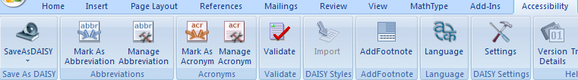

Example: Creating a DAISY Book
- Create a new Microsoft Word document.
- In the Accessibility ribbon, press the Import button to add all the DAISY styles to the Microsoft Word style menu.
- Add the desired content, using the Microsoft Word Styles menu to markup the appropriate text information. If authoring math content, use MathType to add the appropriate math and science notation. If using images, add text descriptions to the relevant images.
- Save the document.
- In the Accessibility ribbon, press the Validate button to assess the validity of the document for conversion to the DAISY format.
- In the Accessibility ribbon, press Save As DAISY > Full DAISY > Narrator to DTbook to DAISY. This will create a DAISY book with the computer's default voice.

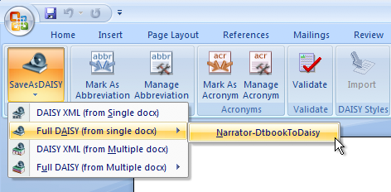

You will be prompted to select the output directory as well as set the document properties, including the title of the file and creator. Generally speaking, the title field would be the title of the book or document and the creator field would be the author(s) of the book.

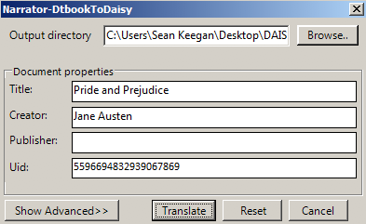

Press "Translate" to begin the process of converting the MS Word document into a full-text/full-audio DAISY book. If MathDAISY has been installed and if there are any MathType objects in the MS Word document, then the result will be a DAISY book with MathML support. Playback of a DAISY book with MathML requires a compatible DAISY player. As of this document, the two software players that support this formatting includes the Easy Reader player (Dolphin Computer Access) and Read Hear (gh-accessibility).

