Blah blah blah blah and this blah blah blah
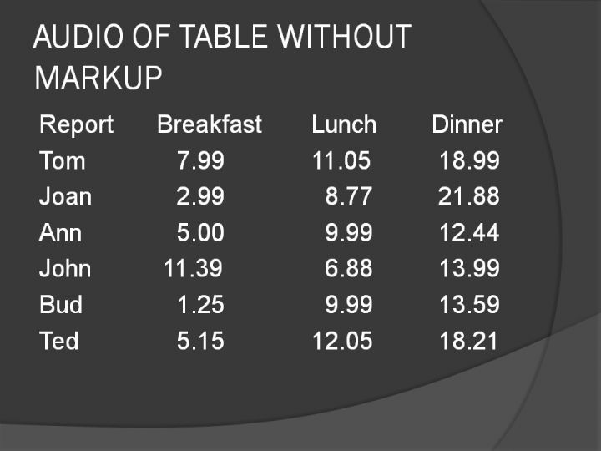This one has “slide20.jpg” as it’s title.

And, then of course there is this…
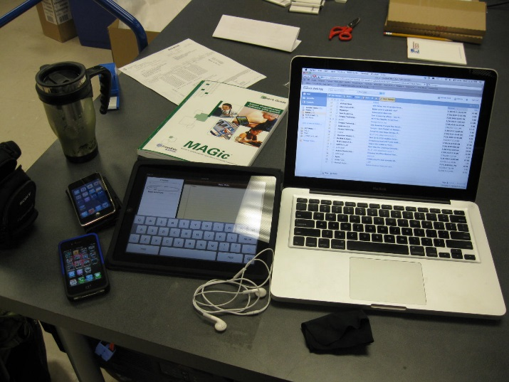 This one is a string of numbers in the alt tag description.

Neither of these images has been correctly tagged with a meaningful alt tag; therefore, a screen reader (JAWS, Voiceover, etc.) will read exactly what is in either the title or the description. In your case, the long string of numbers and only text “image”. What can happen is when an image is inserted it retains the original “save title as:” whatever string of numbers designated by the camera or camera software. Most people never bother to change it because they 1) don’t realize they can, 2) don’t know about UDL/Alt text.
If you have access to the original word document, you could right-click on the image. Go to “format picture,” and then click on “layout and properties” and find “alt text” and make the corrections. A pain but…

