Presented by AHEAD in collaboration with ATHEN

19th Annual Accessing Higher Ground
Accessible Media, Web and Technology Conference
November 14-18, 2016

Call for Proposals

Accessing Higher Ground
Accessible Media, Web & Technology Conference
November 14-18, 2016

Westin Hotel - Westminster, CO
(midway between Denver & Boulder)

AHEAD & ATHEN invite speaker proposals for its 19th annual Accessing Higher Ground Conference.

The conference focuses on:
- The implementation and benefits of assistive technology and accessible media in the university, business & public setting
- Legal and policy issues, including ADA and 508 compliance
- The creation of accessible media and information resources, including web pages and library resources
- Faculty training, Universal Design and accessibility in university curriculum

RFP info:
- Fill out the proposal form at the URL below.
- First round deadline: April 22*
*(If needed, a second round RFP will be announced after the April 22 first-round deadline)

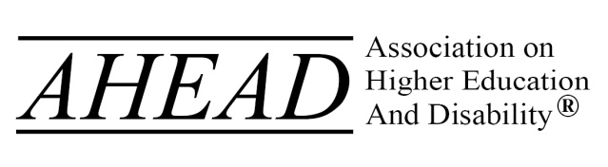
http://accessinghigherground.org
ahg@ahead.org * 303-492-8672

