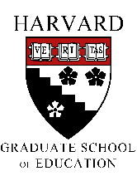
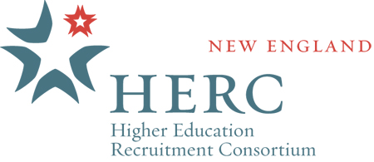
HLS Project on Disability

Disability and Equity @ Work:
The Power of Policy, Myth and Practice from Higher Education to Employment
October 7th, 2016
Gutman Conference Center
6 Apian Way, Cambridge, MA 02138

Co-sponsored by the
Harvard Graduate School of Education Access and Disability Services, OSA, the Harvard Law School Project on Disability, and the New England Higher Education Recruitment Consortium (HERC)

Agenda

8:30 - 9:00 am Registration and Breakfast
Gutman Conference Center
9:00 - 9:05 am Welcome from the conference tri-chair Committee
Eileen Berger, Harvard Graduate School of Education Access and Disability Services, Michael Ashley Stein, Harvard Law School Project On Disability, and Ruth Molina, New England Higher Education Recruitment Consortium (HERC)

9:05 - 9:15 am Welcome Lisa Coleman, Vice President of Diversity and Inclusion Harvard University

Disability and Equity at Work I

9:15 - 9:45 am Professor Michael Stein, Ph.D., J.D. Harvard Law School Visiting Professor

Human rights and equity perspective for people with disabilities. How inclusive policies benefit diverse organizations and gain essential talents of people with disabilities.

Disability and Equity at Work II

9:45 - 10:15 am Professor Thomas Hehir Harvard Graduate School of Education
“How do you get there?’ Elements of academic and professional success for people with disabilities.

10:15 - 10:30 am Q&A with Stein and Hehir

10:30 - 11:00 am Coffee Break and Book Signing
Book Signing
Books by presenters:
Michael Stein, Jonathan Lazar, Thomas Hehir, Bill Henderson, Ron Suskind.

Vendor Tables, Commercial and non-profit vendors

11:00 am - 12:15 pm The Power of Personal Narrative, Askwith Hall Professionals with disabilities discuss their experiences bridging education and employment.

Moderators: Professor Thomas Hehir, Michael Stein, J.D., Ph.D.
Panelists:
Cheri Blauwat, M.D.
Todd Grindal, Ed.D.
Bill Henderson, Ed.D.
Michael Muhue, Ex Dir. Disability Commission, Cambridge
Cui Fengming, Ph.D.
Eric Shed, Ph.D.
12:15 - 1:00 pm Lunch
Attendees return to Gutman Conference Center for a short break and box lunch.

1:00 - 1:45 pm Carol Glazer, President of the National Organization on Disability – Keynote Speaker

Strategies to support employer driven initiatives to recruit and retain employees with disabilities. The work of the National Organization on Disability.

1:45 - 2:15 pm Katherine Petkauskos, Director of Work Without Limits, UMASS Amherst Medical School

Organizational highlights of WorkWithout Limits. Strategies and resources for success.

2:15 - 2:30 pm Afternoon Break

2:30 - 3:30 pm Professor Jonathan Lazar

Access technologies at work. Strategies and solutions that make work environments accessible and sustain employment for People with disabilities.

3:30 - 4:00 pm Conference Wrap up with Professors Michael Stein, HLS, and Tom Hehir, HGSE

4:00 - 5:00 pm Networking Reception
(Corporate sponsors TBD)

For additional information, please visit:

Harvard Graduate School of Education Access and Disability Services

http://www.gse.harvard.edu/osa/access-and-disability-services

Harvard Law School Project on Disability

http://www.hpod.org

New England Higher Education Recruitment Consortium (HERC)

http://www.newenglandherc.org

