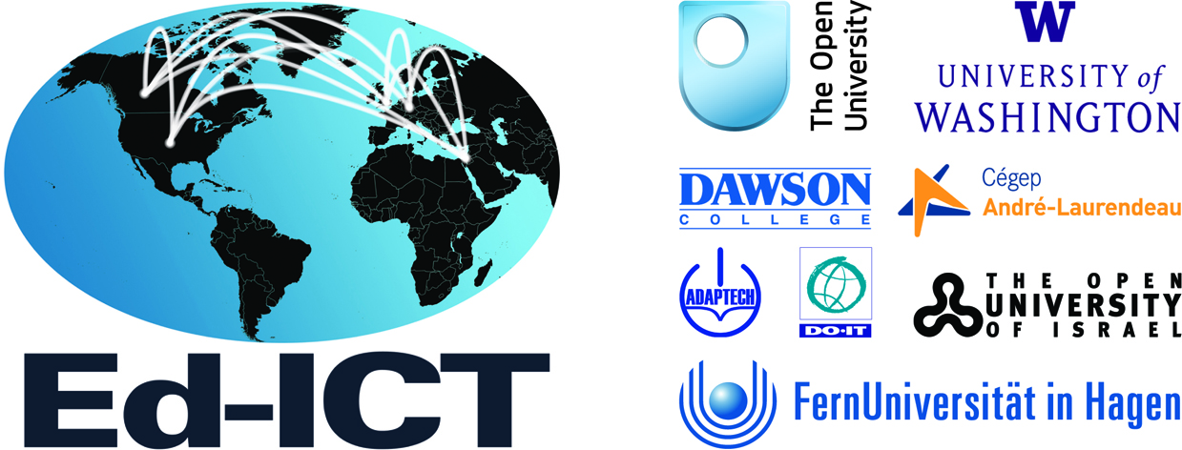

Ed-ICT International Network:
Disabled students, ICT, post-compulsory education & employment:
In search of new solutions

Dear colleague,

I would like to alert you to a new International Research Network and invite you to apply to attend our first symposium to be held March 14-15th 2017 in Seattle. The Ed-ICT International Network focuses on students with disabilities, information and communication technology (ICT), post-compulsory (typically called post-secondary in the U.S) education and employment.

Funded for three years by The Leverhulme Trust, this International Network is co-organized by Jane Seale (The Open University, UK), Tali Heiman (Open University, Israel), Catherine Fichten (Dawson College, Canada), Bjorn Fisseler (FernUniversität, Germany), and Sheryl Burgstahler (University of Washington, US).

ICTs are broadly defined and include computers, mobile devices, assistive technology, online learning and social networking. The Ed-ICT network will explore the role that ICTs play (or could play) in creating or removing barriers for students in post-secondary education. We will be examining these roles in relation to social, emotional and educational outcomes.

The network will also examine how practices of educators and other stakeholders can craft successful and supportive relationships between learners with disabilities and ICT. The network will:

- Synthesize and compare the research evidence that is available across the five countries regarding the relationship between students with disabilities, ICTs and post- secondary education;

- Construct theoretical explanations for why ICTs have not achieved the dramatic reductions in discrimination, disadvantage and exclusion hoped for when equality and non-discrimination-related laws were published across the five countries;

- Explore and develop new perspectives about potential future solutions regarding how post-secondary institutions can better use ICTs to remove the ongoing problems of disadvantage and exclusion of students with disabilities.

In order to meet these objectives we will hold five international symposia over the next three years, each with, respectively, the following broad themes:
- Effective models and frameworks
- New perspectives
- New designs
- Effective practices
- New solutions

Each symposium will include the leadership team from the collaborative countries and 20 stakeholders from the country hosting the meeting. They will include members of multiple groups that include:
- students with disabilities
- faculty and professionals responsible for faculty/staff development;
- professionals responsible for support services for students with disabilities; campus information technology staff;
- digital textbook and resource publishers; and
- senior institutional administrators.

Our first meeting will be held in Seattle March 14-15 2017. There is no registration fee for attendance and students and educators will receive a small stipend of $120 from the Leverhulme Trust to support travel costs associated with their attendance. Group meals at the symposium itself will also be covered by the Trust. In addition, the DO-IT Center has secured funds to cover the cost of hotel rooms for two nights for US participants not representing commercial entities. More information and an application form for attending the Seattle meeting can be found on the project website at ed-ict.com/ (select “International Workshops” and then "Symposium 1"). Apply now as space is limited.

Kind regards,

Sheryl Burgstahler, Ph. D.
Director, UW Accessible Technology Services & DO-IT Center, UW-IT
Affiliate Professor, Education
University of Washington, Box 354842
Seattle, WA 98195
sherylb@uw.edu

