Step 1. Preparing a Word Document from a Text-selectable PDF
The first step is to take a text-selectable PDF and “clean it.” This is the process of rearranging content and deleting images, background colors, tables, etc. Cleaning not only helps INFTY run faster, but it makes the document easier to edit.
Before starting any of the steps below:
- The pages from the source PDF must be extracted.
- Extracted file must be saved separately from the source.

Steps
- Open the PDF.
- Select the Tools option on the right hand.
- Select Edit Text & Images as shown in the image below. Notice that borders appear around text and images.
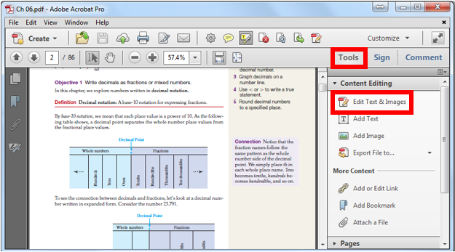
- Delete the following: (To remove the contents of these borders, right-click and select Delete from the resultant menu or select the border and press the Delete key.)

  - Lines/line art.
  - Images.
  - Background.
  - Recurring page headings.
  - Tables.
  - Borders.
  - Shading.
  - Other superfluous decorative features (i.e., "eye candy").

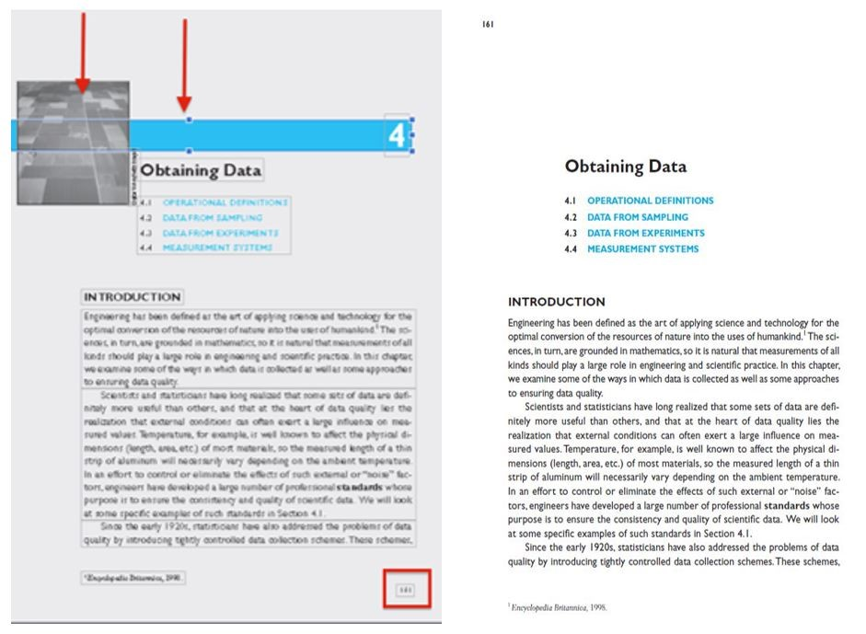
- If something is too time-consuming to remove (like a colored background that refuses to be deleted), leave it and correct it late when editing the Word document.
- INFTY typically makes mistakes with images and when columns of text appear next to each other. When there are multiple columns of texts on a single page (often found in the exercises section towards the end of a section), add blank pages with the keyboard shortcut CTRL+SHIFT+T.
  - BEFORE: Two columns of text on a single page.
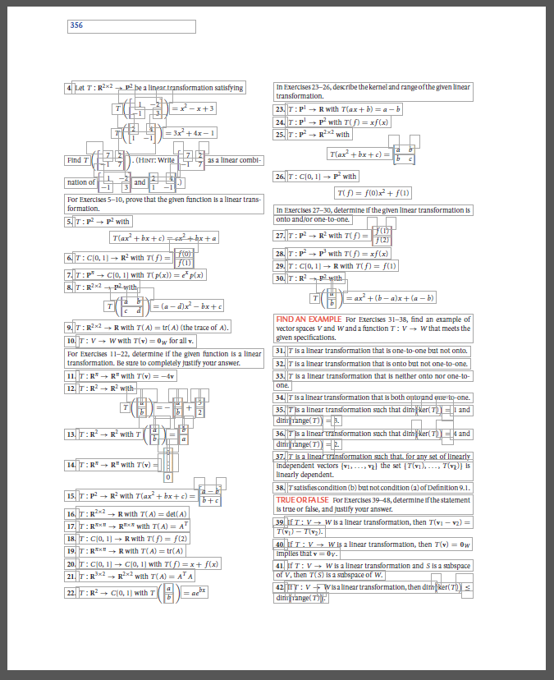
  - AFTER: Two columns of text on two separate pages.
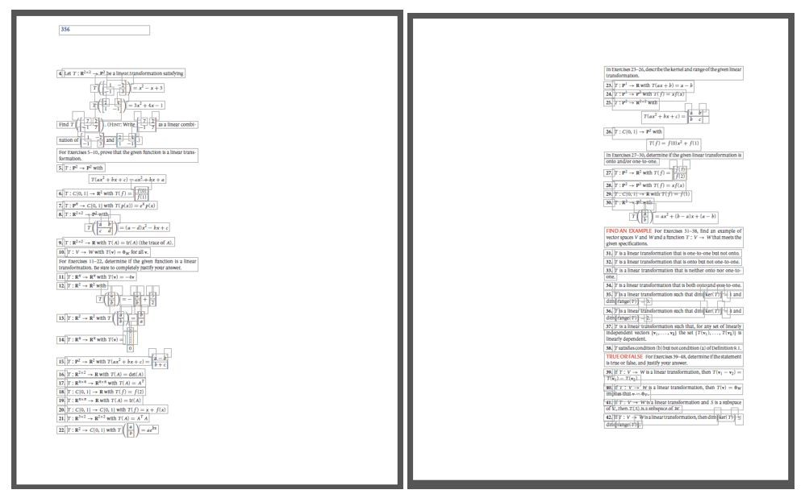
- Make sure page numbers are at the top left of each page. Failure to do so will cause problems when OCR'ing in INFTY. INFTY reads from top to bottom, left to right, so ensure that all text is in a singular column in the correct order.
- When the PDF has been thoroughly cleaned, save the PDF as TIFF images (in a separate folder for every chapter/section). Go to File > Save as other > Image > TIFF.
  - Save these in one folder on your desktop for convenience in the next step. As this folder will be deleted later, naming is not important. Ensure the follow settings are selected:
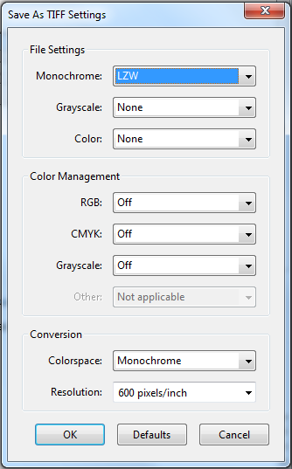

Step 2: INFTY
  - Open up INFTY Reader, not INFTY Layout.
  - Make sure these settings are checked when running INFTY:
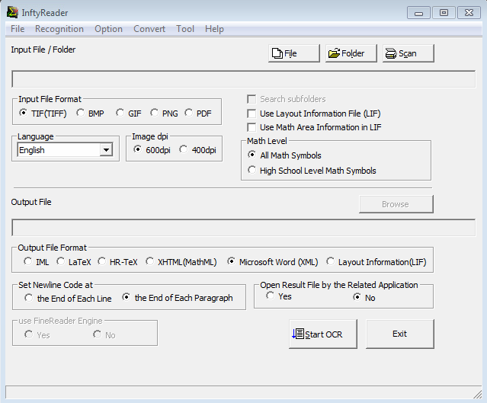
- Select Folder and select desired folder of TIFF images (the one you made at the end of the cleaning process) then select Start.
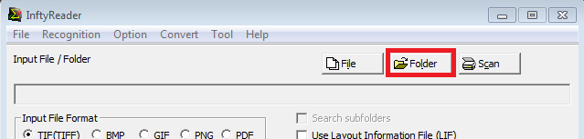
- Once finished, an .xml file will appear in the TIFF folder.
- Save as a Word document (.docx) file.
- Trash the folder of TIFF images, and the log created by INFTY. The only thing you need now is the .docx document.

Troubleshooting INFTY
If INFTY isn't giving an .xml file (i.e., giving a KML file or just a log):
- Check the PDF saving settings to make sure they were set as TIFF images. [Settings.]
- Try splitting TIFF images into smaller batches for INFTY to process. See if processing only 10 – 20 images at a time works. [Less TIFF images]
- If the above steps don’t work, create a folder within the TIFFs folder, and move the images there. Have INFTY process this nested folder. [Longer path name]
- Try to have INFTY process the folder of TIFFs again, a few more times.
- If nothing has worked, process the PDF through ABBYY and manually enter in equations. However, this situation is rare..
- If the output from INFTY is a .kml file instead of .xml, avoid making the output path onto a network drive. Save onto the computer’s hard disk, then move it onto a network drive.

