Google Voice Typing
Google VoiceTyping is the default speech recognition tool for Google Docs and can be used to transcribe audio recordings as well. Either record the output from a connected mobile device or record the output from your computer (an audio/video file).
The advantages of using Google Voice Typing for transcription is that it is free and can transcribe audio with many different speakers. It can also be used to speed up the process of captioning videos.

Transcribing an Audio File (PC)
- Go to Control Panel > Sound
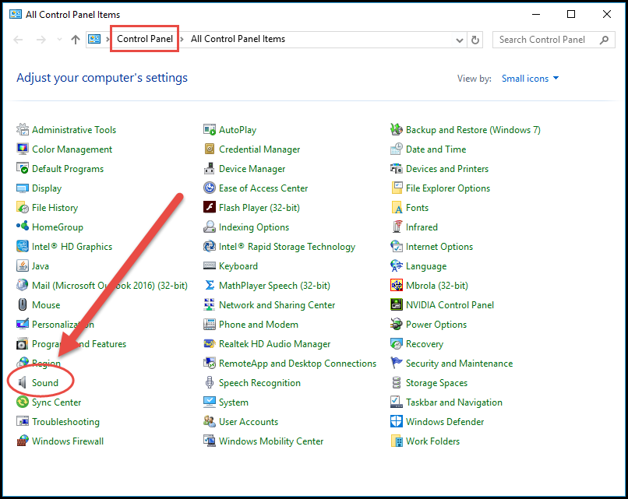
- In the Sound Menu, select the Recording Tab.
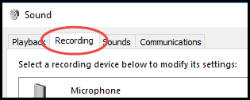

- Right click in menu and select “Show Disabled Devices”. You should now see “Stereo Mix” as a recording device.
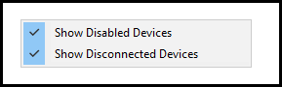
- Right Click on Stereo Mix and select Enable. Your PC is now to record from the computer speaker’s output.
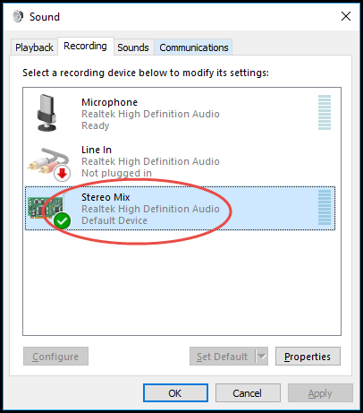
- Log into your Google Account and begin a new Google Doc.
- In Google Docs, go to Tools > Voice Typing or press CTRL + SHIFT + S. The Google VoiceTyping window should now appear.
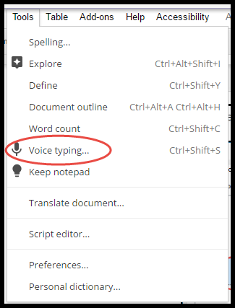
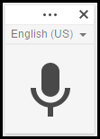
- Open your audio/video file in a media player (e.g., Windows Media Player). Press Play.
- Switch back to Google Docs and click on the Google VoiceTyping microphone. It should now be red.
- The audio will begin transcribing in the Google Doc. Wait for the recording to finish playing.
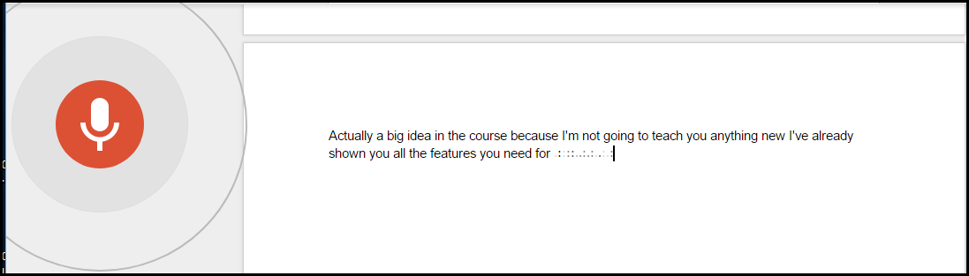
Note: Changing the active window or performing a mouse click will interrupt the transcription.

