Presented by AHEAD in collaboration with ATHEN

21st Annual Accessing Higher Ground
Accessible Media, Web and Technology Conference
November 12-16, 2018

Call for Proposals

Accessing Higher Ground
Accessible Media, Web & Technology Conference
November 12-16, 2018

Westin Hotel - Westminster, CO
(midway between Denver & Boulder)

AHG & AHEAD invite speaker proposals for its 21st annual Accessing Higher Ground Conference.

The conference focuses on:
- The implementation and benefits of Assistive Technology and accessible media in the university, business & public setting
- Legal and policy issues, including ADA and 508 compliance
- The creation of accessible media and information resources, including web pages and library resources
- Alternate format production
- Teaching about Universal Design and accessibility in university curriculum

RFP info:
- Fill out the proposal form at the URL below.
- First round deadline: April 20*
*(If needed, a second round RFP will be announced after the April 20 first-round deadline)

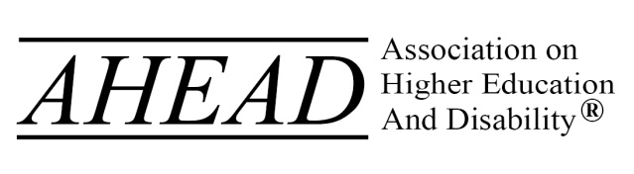
http://accessinghigherground.org
ahg@ahead.org * 303-492-8672

