Livescribe Pen Notes Extraction Tutorial

- Plug in the Livescribe pen. You will hear a beep.

- The Livescribe/Echo Desktop opens automatically when you plug in the pen.

- Find the pages you need, select all of them | Right-click and select “Send # Pages to…

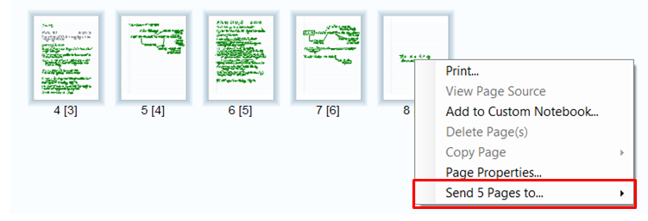

- Select Computer

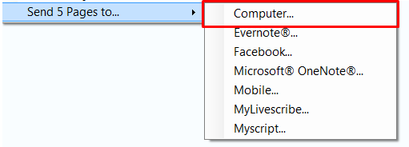

- Sending note to “Computer”

Keep as shown on screen | Click Continue
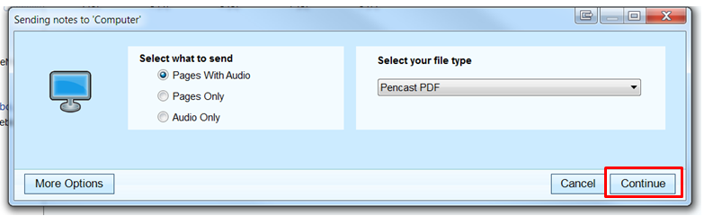

Watch the top bar on the Livescribe Desktop software after you click Continue,

+

The process is shown until complete

- Window popup: Save File As windows

Change the name to “todays” date | Put in Notetaker’s folder @ M:\ATC\Notetakers
Unless instructed to put in another folder

