College Algebra

377

|  |  |  |  |  |
| --- | --- | --- | --- | --- |
| x |  |  | 1 | 2 |
|  |  |  |  |  |

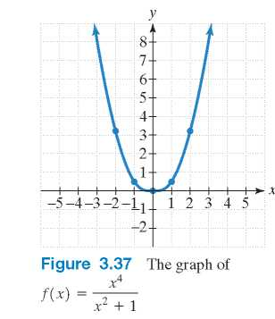

Step 7 Graph the function. Figure 3.37 shows the graph of f using the points obtained from the table and y-axis symmetry. Notice that as x approaches infinity or negative infinity  the function values, f(x) , are getting larger without bound .

Check Point 7 Graph: .

[Sidenote] 7. Identify slant asymptotes. [End Sidenote]

## Slant Asymptotes

Examine the graph of , shown in Figure 3.38. Note that the degree of the numerator, 2, is greater than the degree of the denominator, 1. Thus, the graph of this function has no horizontal asymptote. However, the graph has a slant asymptote, y = x + 1.

The graph of a rational function has a slant asymptote if the degree of the numerator is one more than the degree of the denominator. The equation of the slant asymptote can be found by division. For example, to find the slant asymptote for the graph of , divide into :

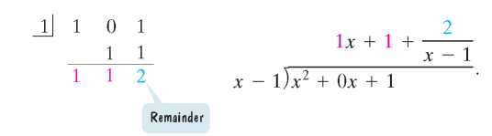

Observe that

Equation.
The equation of the slant asymptote is y= x+1. 

As , the value of  is approximately 0. Thus, when  is large, the function is very close to y = x + 1 + 0. This means that as  or as  the graph of f gets closer and closer to the line whose equation is y = x + 1. The line y = x + 1 is a slant asymptote of the graph.

In general, if , p and q have no common factors, and the degree of p is one greater than the degree of q, find the slant asymptote by dividing q(x) into p(x) . The division will take the form

Equation.
Slant asymptote, y=mx+b

The equation of the slant asymptote is obtained by dropping the term with the remainder. Thus, the equation of the slant asymptote is y = mx + b.

Figure 3.38 The graph of a function with a slant asymptote. 
Slant asymptote, y=x+1
Vertical asymptote, x=1

378

### EXAMPLE 8 Finding the Slant Asymptote of a Rational Function

Find the slant asymptote of .

Solution:

Because the degree of the numerator, 2, is exactly one more than the degree of the denominator, 1, and  is not a factor of , the graph of f has a slant asymptote. To find the equation of the slant asymptote, divide  into :

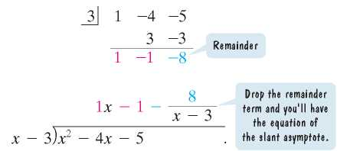

The equation of the slant asymptote is . Using our strategy for graphing rational functions, the graph of  is shown in Figure 3.39.

Figure 3.39 The graph of the function.
Slant asymptote, y=x minus 1
Vertical asymptote, x=3

Check Point 8 Find the slant asymptote of .

[Sidenote] 8. Solve applied problems involving rational functions. [End Sidenote]

## Applications

There are numerous examples of asymptotic behavior in functions that model real-world phenomena. Let's consider an example from the business world. The cost function, C, for a business is the sum of its fixed and variable costs:

Equation.
cx= cost per unit times the number of units produced, x.

The average cost per unit for a company to produce x units is the sum of its fixed and variable costs divided by the number of units produced. The average cost function is a rational function that is denoted by . Thus,

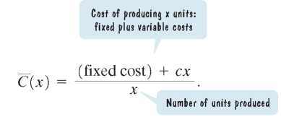

### EXAMPLE 9 Average Cost for a Business

We return to the robotic exoskeleton described in the section opener. Suppose a company that manufactures this invention has a fixed monthly cost of $1,000,000 and that it costs $5000 to produce each robotic system.

a. Write the cost function, C, of producing x robotic systems.

b. Write the average cost function, , of producing x robotic systems.

c. Find and interpret .

d. What is the horizontal asymptote for the graph of the average cost function, ? Describe what this represents for the company.

379



Solution:

a. The cost function, C, is the sum of the fixed cost and the variable costs.

Equation.
Fixed cost is $1,000,000.
Variable cost, $5,000 for each robotic system produced. 

b. The average cost function, , is the sum of fixed and variable costs divided by the number of robotic systems produced.



c. We evaluate  at 1000, 10,000, and 100,000, interpreting the results.



The average cost per robotic system of producing 1000 systems per month is $6000.



The average cost per robotic system of producing 10,000 systems per month is $5100. 

The average cost per robotic system of producing 100,000 systems per month is $5010. Notice that with higher production levels, the cost of producing each robotic exoskeleton decreases.

d. We developed the average cost function



in which the degree of the numerator, 1, is equal to the degree of the denominator, 1. The leading coefficients of the numerator and denominator, 5000 and 1, are used to obtain the equation of the horizontal asymptote. The equation of the horizontal asymptote is

 or y = 5000.

The horizontal asymptote is shown in Figure 3.40. This means that the more robotic systems produced each month, the closer the average cost per system for the company comes to $5000. The least possible cost per robotic exoskeleton is approaching $5000. Competitively low prices take place with high production levels, posing a major problem for small businesses.

Figure 3.40 Walk Man; HAL's Average Cost.
Domain; Number of Robotic Exoskeletons Produced per Month (1000 to 6000).
Range; Average Cost per Exoskeleton for the Company ($4000 top $10,000). 

Check Point 9: A company is planning to manufacture wheelchairs that are light, fast, and beautiful. The fixed monthly cost will be $500,000 and it will cost $400 to produce each radically innovative chair.

a. Write the cost function, C, of producing x wheelchairs.

b. Write the average cost function, , of producing x wheelchairs.

c. Find and interpret .

d. What is the horizontal asymptote for the graph of the average cost function, ? Describe what this represents for the company.

380

## Exercise Set 3.5

### Practice Exercises

In Exercises 1-8, find the domain of each rational function.

1. 

2. 

3. 

4. 

5. 

6. 

7. 

8. 

Use the graph of the rational function in the figure shown to complete each statement in Exercises 9-14.

Graph.
Vertical asymptote, x= negative 3, and x=1.
Horizontal asymptote, y=0. 

9. As ,  [blank].

10. As ,  [blank].

11. As ,  [blank].

12. As ,  [blank].

13. As ,  [blank].

14. As ,  [blank].

Use the graph of the rational function in the figure shown to complete each statement in Exercises 15-20.

Graph.
Vertical asymptotes, x= negative 2 and x=1.
Horizontal asymptote, y=1.

15. As ,  [blank].

16. As ,  [blank].

17. As ,  [blank].

18. As ,  [blank].

19. As ,  [blank].

20. As ,  [blank].

In Exercises 21-28, find the vertical asymptotes, if any, of the graph of each rational function.

21. 

22. 

23. 

24. 

25. 

26. 

27. 

28. 

In Exercises 29-36, find the horizontal asymptote, if any, of the graph of each rational function.

29. 

30. 

31. 

32. 

33. 

34. 

35. 

36. 

In Exercises 37-48, use transformations of  or  to graph each rational function.

37. 

38. 

39. 

40. 

41. 

42. 

43. 

44. 

45. 

46. 

47. 

48. 

In Exercises 49-70, follow the seven steps on page 373 to graph each rational function.

49. 

50. 

51. 

52. 

53. 

54. 

55. 

56. 

57. 

58. 

59. 

60. 

61. 

62. 

63. 

64. 