Physics

158

How is it that a larger area of contact doesn't produce a larger force? One way to think about this is to consider that when the area of contact is large, the normal force is spread out over a large area, giving a small force per area, . As a result, the microscopic hills and valleys are not pressed too deeply against one another. On the other hand, if the area is small, the normal force is concentrated in a small region, which presses the surfaces together more firmly, due to the large force per area. The net effect is roughly the same in either case.

The next Example considers a commonly encountered situation in which kinetic friction plays a decisive role.

[side note] PROBLEM-SOLVING NOTE

Choice of Coordinate System: Incline

On an incline, align one axis (x) parallel to the surface, and the other axis (y) perpendicular to the surface. That way the motion is in the x direction. Since no motion occurs in the y direction, we know that . [end sidenote]

[side note]

EXAMPLE 6-1 Pass the Salt—Please

Someone at the other end of the table asks you to pass the salt. Feeling quite dashing, you slide the 50.0-g salt shaker in that direction, giving it an initial speed of 1.15 m/s. (a) If the shaker comes to rest with constant acceleration in 0.840 m, what is the coefficient of kinetic friction between the shaker and the table? (b) How much time is required for the shaker to come to rest if you slide it with an initial speed of 1.32 m/s?

PICTURE THE PROBLEM

We choose the positive x direction to be the direction of motion, and the positive y direction to be upward. Two forces act in the y direction: the shaker's weight, , and the normal force, . Only one force acts in the x direction: the force of kinetic friction, . Notice that the shaker moves through a distance of 0.840 m with an initial speed .

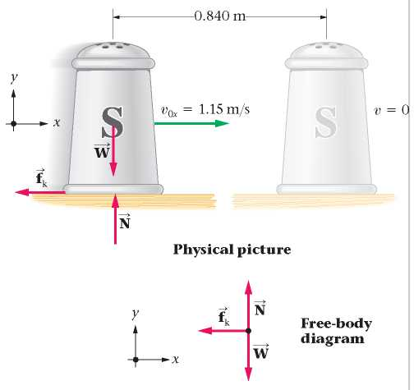

REASONING AND STRATEGY

a. The frictional force has a magnitude of , and hence it follows that . Therefore, we need to find the magnitudes of the frictional force, , and the normal force, N, to determine . To find  we set , and find  with the kinematic equation . To find N we set  (since there is no motion in the y direction) and solve for N using .

b. The coefficient of kinetic friction is independent of the sliding speed, and hence the acceleration of the shaker is also independent of the speed. As a result, we can use the acceleration from part (a) in the equation  to find the sliding time.

Known: Mass of salt shaker, m = 50.0 g; initial speed,  or 1.32 m/s; sliding distance, .

Unknown: (a) Coefficient of kinetic friction,  (b) Time to come to rest, t = [blank]?

SOLUTION

Part (a)

1. Set  to find  in terms of :

 or 

2. Determine  by using the kinematic equation relating velocity to position, :



  

3. Set  to find the normal force, N:

 or 

4. Substitute N = mg and  (with ) into  to find :

 

Part (b)

5. Use , , and  in  to solve for the time, t:

 or



INSIGHT

Notice that m canceled in Step 4, so our result for the coefficient of friction is independent of the shaker's mass. For example, if we were to slide a shaker with twice the mass, but with the same initial speed, it would slide the same distance. It's unlikely this independence would have been apparent if we had worked the problem numerically rather than symbolically. Part (b) shows that the same comments apply to the sliding time—it too is independent of the shaker's mass.

[side note continues]

159

[side note continued]

PRACTICE PROBLEM

Given an initial speed of 1.15 m/s and a coefficient of kinetic friction equal to 0.120, what are (a) the acceleration of the shaker and (b) the distance it slides?

[Answer: (a) , (b) 0.560 m]

Some related homework problems: Problem 3, Problem 13

[end sidenote]

In the next Example, the system is inclined at an angle  relative to the horizontal. As a result, the normal force responsible for the kinetic friction is less than the weight of the object.

[side note]

EXAMPLE 6-2 making a big splash

A trained sea lion slides from rest with constant acceleration down a 3.0-m-long ramp into a pool of water. If the ramp is inclined at an angle of  above the horizontal and the coefficient of kinetic friction between the sea lion and the ramp is 0.26, how much time does it take for the sea lion to make a splash in the pool?

PICTURE THE PROBLEM

As is usual with inclined surfaces, we choose one axis to be parallel to the surface and the other to be perpendicular to it. In our sketch, the sea lion accelerates in the positive x direction (), having started from rest, . We are free to choose the initial position of the sea lion to be . There is no motion in the y direction, and therefore . Finally, we note from the free-body diagram that , , and .

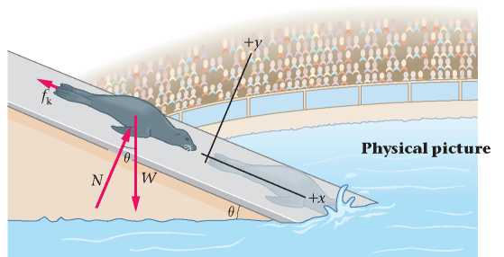

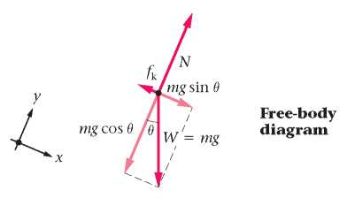

REASONING AND STRATEGY

We can use the kinematic equation relating position to time, , to find the time of the sea lion's slide. It will be necessary, however, to first determine the acceleration of the sea lion in the x direction, .

To find  we apply Newton's second law to the sea lion. First, we can find N by setting  equal to zero (since ). It is important to start by finding N because we need it to find the force of kinetic friction, . Using  in the sum of forces in the x direction, , allows us to solve for  and, finally, for the time.

Known: Length of ramp, x = 3.0 m; angle of incline, ; coefficient of kinetic friction, .

Unknown: Sliding time, t = [blank]?

SOLUTION

1. We begin by resolving each of the three force vectors into x and y components:

 

  

 

2. Set  to find N.

We see that N is less than the weight, mg:





3. Next, set .

Notice that the mass cancels in this equation:





4. Solve for the acceleration in the x direction, :







[side note continues]

160

[side note continued]

5. Use  to find the time when the sea lion reaches the bottom. We choose , and we are given that ; hence we set  m and solve for t:





INSIGHT

We don't need the sea lion's mass to find the time. On the other hand, if we wanted the magnitude of the force of kinetic friction, , the mass would be needed.

It is useful to compare the sliding salt shaker in Example 6-1 with the sliding sea lion in this Example. In the case of the salt shaker, friction is the only force acting along the direction of motion (opposite to the direction of motion, in fact), and it brings the object to rest. Because of the slope on which the sea lion slides, however, it experiences both a component of its weight in the forward direction and the frictional force opposite to the motion. Because the component of the weight is the larger of the two forces, the sea lion accelerates down the slope—friction only acts to slow its progress.

PRACTICE PROBLEM

How much time would it take the sea lion to reach the water if there were no friction in this system? [Answer: 1.3 s]

Some related homework problems: Problem 4, Problem 58

[end sidenote]

### Static Friction

Static friction tends to keep two surfaces from moving relative to one another. Like kinetic friction, it is due to the microscopic irregularities of surfaces that are in contact. In fact, static friction is typically stronger than kinetic friction because when surfaces are in static contact, their microscopic hills and valleys nestle down deeply into one another, forming a strong connection between the surfaces. In kinetic friction, the surfaces bounce along relative to one another and don't become as firmly enmeshed. Static friction also depends on lubrication, as illustrated in FIGURE 6-4.

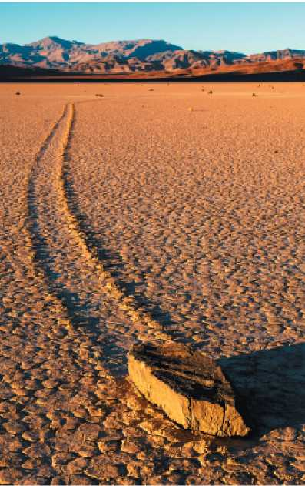

[caption] FIGURE 6-4

The coefficient of static friction between two surfaces depends on many factors, including whether the surfaces are dry or wet. On the desert floor of Death Valley, California, occasional rains can reduce the friction between rocks and the sandy ground to such an extent that strong winds can move the rocks over considerable distances. This results in linear "rock trails," which record the direction of the winds at different times. [end caption]

As we did with kinetic friction, let's use the results of some simple experiments to determine the rules of thumb for static friction. We start with a brick at rest on a table, with no horizontal force pulling on it, as in FIGURE 6-5. Of course, in this case the force of static friction is zero; no force is needed to keep the brick from sliding.

Figure 6-5 Diagram of someone pulling a brick using a spring with a hook.
Static friction can have a magnitude of zero, or greater than zero, up to a maximum value. Once sliding begins, however, the friction is kinetic and has a magnitude less than the maximum value for static friction.

[caption] FIGURE 6-5 The maximum limit of static friction

As the force applied to an object increases, so does the force of static friction—up to a certain point. Beyond this maximum value, static friction can no longer hold the object, and it begins to slide. Now kinetic friction takes over. [end caption]

Next, we attach a spring scale to the brick and pull with a small force of magnitude , a force small enough that the brick doesn't move.

161

Since the brick is still at rest, it follows that the force of static friction, , is equal in magnitude to the applied force; that is,  Now, we increase the applied force to a new value, , which is still small enough that the brick stays at rest. In this case, the force of static friction has also increased so that . If we continue increasing the applied force, we eventually reach a value beyond which the brick starts to move and kinetic friction takes over, as shown in the figure. It follows that there is a maximum force, , that can be exerted by static friction. Thus, the force of static friction, , can have any value between 0 and :

equation 6-2

Imagine repeating the experiment, only now with a second brick on top of the first. This doubles the normal force and it also doubles the maximum force of static friction. Thus, the maximum force is proportional to the magnitude of the normal force; that is,

equation 6-3

The constant of proportionality is called  (pronounced "mew sub s"), the coefficient of static friction. Notice that  is dimensionless, just like mk. Typical values are given in Table 6-1. In most cases,  is greater than , indicating that the force of static friction is greater than the force of kinetic friction. In some cases, like rubber in contact with dry concrete,  is greater than 1.

Two additional experimental results regarding static friction are important: (i) Static friction, like kinetic friction, is independent of the area of contact. (ii) The force of static friction is parallel to the surface of contact, and opposite to the direction the object would move if there were no friction. All of these observations are summarized in the following rules of thumb:

[side note]

Rules of Thumb for Static Friction

The force of static friction between two surfaces has the following properties:

1. It takes on any value between zero and the maximum possible force of static friction, :



2. It is independent of the area of contact between the surfaces.

3. It is parallel to the surface of contact, and in the direction that opposes relative motion.

[end sidenote]

The next Example presents a practical method of determining the coefficient of static friction in a real-world system.

[side note]

EXAMPLE 6-3 slightly tilted

A flatbed truck slowly tilts its bed upward to dispose of a 95.0-kg crate. For small angles of tilt the crate stays put, but when the tilt angle exceeds , the crate begins to slide. What is the coefficient of static friction between the bed of the truck and the crate?

PICTURE THE PROBLEM

We align our coordinate system with the incline, and choose the positive x direction to point down the slope. Three forces act on the crate: the normal force, , the force of static friction, , and the weight, .

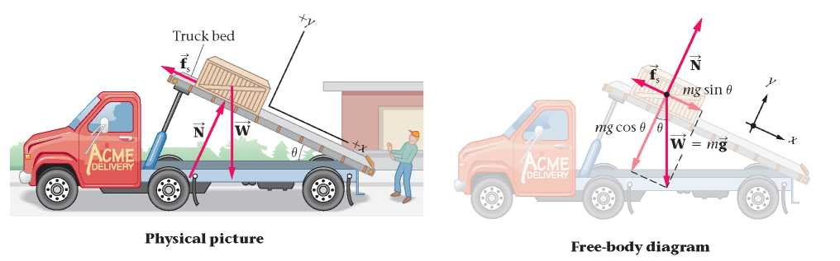

[side note continues]

162

[side note continued]

REASONING AND STRATEGY

When the crate is on the verge of slipping, but has not yet slipped, its acceleration is zero in both the x and y directions. In addition, "on the verge of slipping" means that the magnitude of the static friction is at its maximum value, . Thus, we set  to find N, and then use  to find .

Known: Mass of crate, m = 95.0 kg; critical tilt angle, .

Unknown: Coefficient of static friction,  = [blank]?

SOLUTION

1. Resolve the three force vectors acting on the crate into x and y components:

 

 

 

2. Set , since . Solve for the normal force, N:





3. Set , since the crate is at rest, and use the result for N obtained in Step 2:

 





4. Solve the expression for the coefficient of static friction, :





INSIGHT

In general, if an object is on the verge of slipping when a surface is tilted at a critical angle , the coefficient of static friction between the object and the surface is . This result is independent of the mass of the object. For example, the critical angle for this crate is precisely the same whether it is filled with feathers or lead bricks. Real-world examples of the critical angle are found in hourglasses and talus slopes, as shown in FIGURE 6-6.

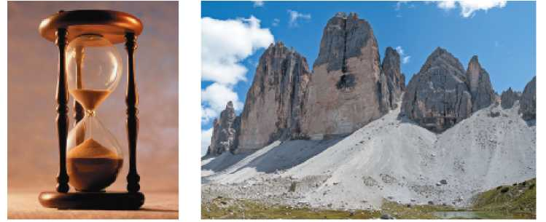

[caption] FIGURE 6-6 Visualizing Concepts Talus Slope

The angle that the sloping sides of a sand pile (left) make with the horizontal is determined by the coefficient of static friction between the grains of sand, in much the same way that static friction determines the angle at which the crate in Example 6-3 begins to slide. The same basic mechanism determines the angle of the cone-shaped mass of rock debris at the base of a cliff—known as a talus slope (right). [end caption]

PRACTICE PROBLEM

Find the magnitude of the force of static friction acting on the crate just before it starts to slide. [Answer: ]

Some related homework problems: Problem 9, Problem II

[end sidenote]

Recall that static friction can have a magnitude that is less than its maximum possible value. This point is emphasized in the next Example.

[side note]

QUICK EXAMPLE 6-4 the force of static friction

In Example 6-3, what is the magnitude of the force of static friction acting on the crate when the truck bed is tilted at an angle of 20.0°?

REASONING AND SOLUTION

The crate is at rest, and hence its acceleration is zero in the x direction: . This condition determines the magnitude of the static friction force necessary to hold the crate in place.

1. Sum the x components of force acting on the crate:



[side note continues]

163

[side note continued]

2. Set this sum equal to zero (since ) and solve for the magnitude of the static friction force, :



3. Substitute numerical values, including :



The force of static friction in this case has a magnitude of 319 N, which is less than the value of 367 N found in the Practice Problem in Example 6-3, even though the coefficient of static friction is precisely the same.

[end sidenote]

Finally, friction often enters into problems that involve vehicles with rolling wheels. In Conceptual Example 6-5, we consider which type of friction is appropriate in such cases.

[side note]

CONCEPTUAL EXAMPLE 6-5 friction for rolling tires

A car drives with its tires rolling freely. Is the friction between the tires and the road (a) kinetic or (b) static?

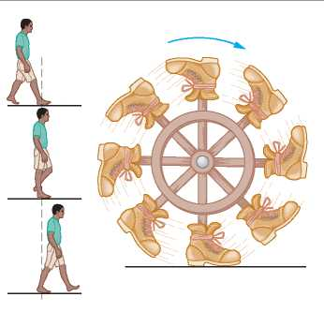

REASONING AND DISCUSSION

A reasonable-sounding answer is that because the car is moving, the friction between its tires and the road must be kinetic friction—but this is not the case.

Actually, the friction is static because the bottom of the tire is in static contact with the road. To understand this, watch your feet as you walk. Even though you are moving, each foot is in static contact with the ground once you step down on it. Your foot doesn't move again until you lift it up and move it forward for the next step. A tire can be thought of as a succession of feet arranged in a circle, each momentarily in static contact with the ground.

ANSWER

(b) The friction between rolling tires and the road is static friction.

[end sidenote]

RWP [see footnote *]

[footnote *] Real World Physics applications are denoted by the acronym RWP. [end footnote]

If a car skids, the friction acting on it is kinetic; if its wheels are rolling, the friction is static. Static friction is generally greater than kinetic friction, however, and hence it follows that a car can be stopped in a shorter distance if its wheels are rolling (static friction) than if its wheels are locked up (kinetic friction). This is the idea behind the antilock braking systems (ABS) that are available on many cars. When the brakes are applied in a car with ABS, an electronic rotation sensor at each wheel detects whether the wheel is about to start skidding. To prevent skidding, a small computer automatically begins to pulse the hydraulic pressure in the brake lines in short bursts, causing the brakes to release and then reapply in rapid succession. This allows the wheels to continue rotating, even in an emergency stop, and for static friction to determine the stopping distance. FIGURE 6-7 shows a comparison of braking distances for cars with and without ABS. An added benefit of ABS is that a driver is better able to steer and control a braking car if its wheels are rotating. An illustration of the danger posed by locked wheels is presented in FIGURE 6-8.

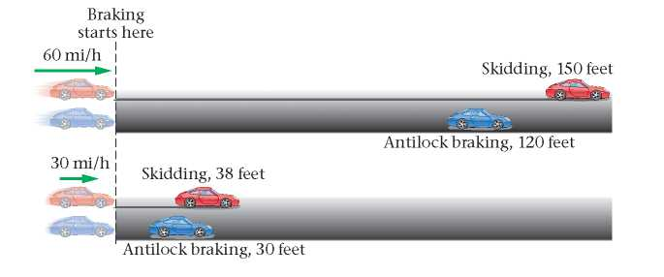

[caption] FIGURE 6-7 Stopping distance with and without ABS

Antilock braking systems (ABS) allow a car to stop with static friction rather than kinetic friction—even in a case where a person slams on the brakes. As a result, the braking distance is reduced. Professional drivers can beat the performance of ABS by carefully adjusting the force they apply to the brake pedal during a stop, but ABS provides essentially the same performance—within a few percent—for a person who simply pushes the brake pedal to the floor and holds it there. [end caption]