Accessibility Evaluation- Buckeye Careers Handshake Application
Prepared by
- Katie Frederick, Digital Accessibility Specialist
- Peter Bossley, Director
- Julia Novakowski, Systems Analyst
- Rahim Abdi, OCIO Accessibility Analyst
February 2018.
Evaluation was requested by Megan Miller, Assistant Director, Career Technology & Operations, Office of Student Life, Buckeye Careers. First correspondence was February 12, 2018.
Overall System Accessibility Health Rating: Fair
Expected Risk: High

Executive Summary
The accessibility evaluation was conducted with NVDA 2017.4 and Firefox ESR 52. Three interface modes were evaluated: career staff, employer, and student. Color contrast testing was conducted using The Paciello Group Color Contrast Analysis tool. Global and site wide issues may be individually called out on certain pages throughout the application, however, not every example would have been documented. Similarly, not every interface and every page was tested; a representative sample was identified for testing. To the extent that similar design patterns were used in other areas of the application, accessibility issues and remediation advise provided in this report would likely apply to those areas as well. The following high-level issues were present:
- Visual keyboard focus indication should be improved.
- Pages lack unique and orienting titles.
- Illogical tab order is found throughout the interfaces.
- Many pages lack logical and sequential heading structures.
- ARIA or HTML landmarks are inconsistent. Pages should contain at least a main, and one or more navigation landmarks. Other landmark types e.g. search, contentinfo, banner, etc should be used when appropriate to the semantic structure of the page. Where multiple landmarks of one type e.g. navigation landmarks are present on a page, each of these duplicated landmark types should have an accessible name using an acceptable labelling technique such as aria-label or aria-labeledby.
- Color contrast issues exist throughout; ratios of 2.5:1 to 4.1:1 do not meet WCAG 2.0 AA color contrast requirements of 4.5:1.
- When navigation actions are completed that trigger partial page refreshes, no notification is provided to screen reader users that anything has occurred; furthermore when actions are completed that load new content, focus is often times not placed in a logical location at the top of the newly loaded content.
- When filtering or other actions are completed, no notification is provided to screen reader users that anything has occurred.
- All three interface modes career staff, employer, and student contained similar accessibility issues.

Recommendation
Buckeye Careers should engage the vendor to remediate issues in this report in consultation with the Digital Accessibility Center.

General (Site-wide) Issues
•Page titles need improvement. Page titles should be unique and orienting. E.g. Home Page – handshake, Login – Handshake, Interview Schedules – handshake, etc.
•Throughout the three interface models evaluated, a “skip to main content” link is not present. A skip to main content link should be the first item in the DOM and should place the focus on an H1 that denotes the beginning of the main content of the page.
•There are Illogical heading structures present throughout the interfaces. Headings should descend logically and sequentially with the main content of the page beginning at an H1.
- type ahead controls found throughout the interfaces present numerous accessibility problems for screen reader reliant users.
  - In all cases, the type aheads do not report to screen reader users that search results are available. Nor is this information conveyed as it changes as users type.
  - In some cases, keyboard and screen reader users are able to arrow through the available results. E.g. in the global search interface. However, in other cases, using the arrow keys moves through available options, but no indication is provided to screen reader or keyboard users that a result is focused.
  - In all cases, no notification is provided to screen reader users when or if they make a selection.
  - For an example of a fully accessible autocomplete widget, please see: https://assets.cms.gov/resources/framework/3.4.1/Pages/#autocomplete
- Visual keyboard focus indication needs improvement. We recommend that the keyboard focus indication ring pass WCAG 2.0 AA CCR of 4.5:1 for regular sized text.
- Throughout the site, where anchor tags have <span> tags containing the link text, certain screen reader and browser combinations cause the target of the href to be read instead of the link text when tabbing to the links in question.
- Throughout the site, some pages contain multiple controls with a single label e.g. edit or add; these controls need more context as to what they apply to e.g. add work experience, edit (job title) (company).
- Some pages contain links that need more context, the destination of links should be apparent through the link text alone.

Login Page
- Visual keyboard focus indication should be improved. The focus ring needs to be more prominent.
- The page title needs to be more descriptive. Page titles should be unique and orienting.

Interface Mode: Career Services Staff View

Page-level Issues

Main page
- The page title needs improvement. Page titles should be unique, and orienting, for example, “Home Page - handshae.”
- No “skip to main content” link is present on this page.
- No ARIA or HTML landmarks exist. Pages should contain at least a main, and one or more navigation landmarks. Other landmark types e.g. search, contentinfo, banner, etc should be used when appropriate to the semantic structure of the page. Where multiple landmarks of one type e.g. navigation landmarks are present on a page, each of these duplicated landmark types should have an accessible name using an acceptable labelling technique such as aria-label or aria-labeledby.
- Heading structures need improvement. Currently there is no H1 present. The main content of the page should begin at H1 and descend logically and sequentially throughout the page. “Appointments” is labeled as an H3 and is the first heading that is navigable.
- The summary information below each category of the student activity snapshot lacks sufficient color contrast. The ratio is 2.4:1.
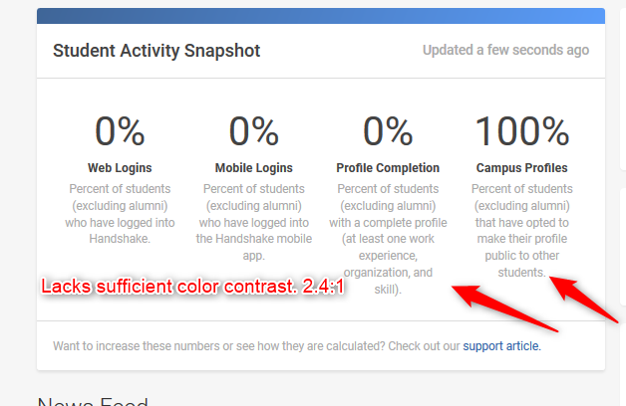
- There is an illogical tab order for keyboard reliant users. When tabbing through the top level menu bar there are issues present. When navigating from “name” to “help” to “globe,” the navigation is from right to left. This is illogical. Tab order should follow a logical sequence. The image below demonstrates the current order. This should be reversed.
  - Note: The most important issue in tab order is the order of the elements in the DOM, since keyboard and screen readers will naturally focus UI elements in the order that they appear in the DOM, regardless of the use of CSS to float content into position. It is not advisable to manually manipulate tab order using positive tabindex values as this technique can lead to inconsistent behaviors, especially in cases where all elements are not manually set using an appropriate tabindex value.

- Multiple links on the page lack descriptive link text. The links are ambiguous as to their purpose.
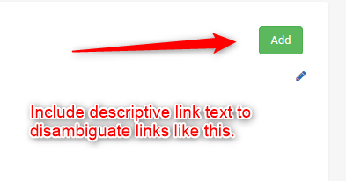

- The Menu buttons on this page are problematic for keyboard and screen reader reliant users.
  - When menu buttons are activated by keyboard and screen reader reliant users, focus should be placed on the first submenu element.
  - The up and down arrow keys should then move sequentially through the menu items, when focus moves to the last menu item, a further press of the down arrow should wrap back to the first item. The reverse is true when using up arrow to move up in the list.
  - Pressing escape should collapse the menu and place focus back on the triggering element.
  - The menu buttons on this page do not adhere to the ARIA Authoring Practices menu button pattern. See: https://www.w3.org/TR/wai-aria-practices-1.1/#menubutton
    - Note: careful attention to use of the appropriate aria roles, states, and values, as well as roving tabindex are all essential to proper function for screen reader users. Any extraneous role definitions or improper tabindex roving will likely result in missing functionality for screen reader users.
  - The “help” menu button and other menu buttons present the same problematic issues for keyboard and screen reader users.
  - Under Help, a keyboard reliant user is unable to navigate to the Training submenu item.
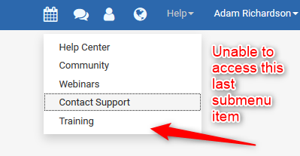

- Navigation Region Issues
  - The expand collapse E.G. students in the navigation region are inaccessible to keyboard or screen reader reliant users.
  - The navigation region- headings E.G. students, posting- these denote categories and navigation links- the headings do not pass color contrast analysis.
  - The navigation region should have a heading of appropriate level with a unique ID (off screen if desired for visual design purposes) and the navigation region should point to this heading as its accessible name using aria-labeledby pointing to the ID of the heading. The currently selected link should have aria-current=true.
- The home button (link labeled logo) needs improved link text, such as “Handshake Homepage.”
- Visual keyboard Focus indication Issues exist throughout this interface.
- The visual keyboard focus indication for keyboard reliant or low vision users is insufficient and needs improvement. We recommend that the keyboard focus indication ring pass WCAG 2.0 CCR of 4.5:1 for regular sized text.
  - Currently there is a light blue box used on top of a dark gray background.
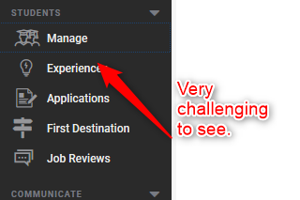
- A video pop-up appears, (at random times), presenting accessibility issues for keyboard and screen reader reliant users; as a result, the video’s controls are largely inaccessible.
  - When the video pop up appears on the page, no notification is provided to a screen reader reliant user except for a beep sound. Keyboard and screen reader reliant users can not close the pop-up once it is open. There is an X to close the pop-up labeled “link,” this requires more descriptive link text. The visual focus indication needs improvement for keyboard users to access the video pop-up and controls.
  - This video should be implemented as an accessible modal dialog, following requirements in the ARIA authoring practices. https://www.w3.org/TR/wai-aria-practices-1.1/#dialog_modal
    - As with other widget roles, careful attention is required to ensure that the widget is built strictly according to this specification; failure to adopt the specification properly will likely result in accessibility issues for screen reader or keyboard users.

Profile

Profile Page
- There are no ARIA or HTML landmarks on this page. Pages should contain at least a main, and one or more navigation landmarks. Other landmark types e.g. search, contentinfo, banner, etc should be used when appropriate to the semantic structure of the page. Where multiple landmarks of one type e.g. navigation landmarks are present on a page, each of these duplicated landmark types should have an accessible name using an acceptable labelling technique such as aria-label or aria-labeledby.
- Color contrast on the text of the links in the profile navigation area (profile, account, calendar,) lack sufficient color contrast; the ratio is 4.1:1. WCAG 2.0 AA requires a minimum CCR of 4.5:1.
- The profile navigation area should be wrapped in a <nav> navigation region, in addition, there should be a heading of appropriate level e.g. H2 that says “profile navigation.” The navigation region should point to this heading’s ID as an accessible name using aria-labeledby.
- When a link is activated within this navigation region, focus lands in a random location. pressing tab key moves focus to the beginning of the main navigation region on the left side of the page. This is disorienting for keyboard and screen reader reliant users. When user navigation results in a partial page refresh, focus should be logically placed at the H1 that represents the beginning of the main content of the page, or, alternatively, a heading of appropriate level that is at the top of the newly loaded content.
- The currently active page within the profile navigation area should have aria-current=true applied to provide this context to screen reader users.
- Heading structure is not logical on this page.
- There are controls to add work experience and external links. Both of these controls are labeled “add” and it is unclear which action the controls reference. These controls should be disambiguated as to their purposes. E.g. Add work experience.
- No notification is provided to screen reader reliant users when work history or external links are activated. Furthermore, focus is dropped in a random location when new content loads. After actions are completed, notification of the success or failure of actions should be provided to screen reader users; furthermore focus should be set to a logical location.
- When adding a work experience entry the job function select lacks a properly associated descriptive label. Furthermore, the start and end date fields need more descriptive labels. Start and end are not sufficient to identify the purpose of these fields. The labels could be adjusted to start date or end date.
- These form fields should be wrapped in a fieldset with an appropriately descriptive legend.
- There is a location type ahead control that presents numerous accessibility problems for keyboard and screen reader reliant users. The type ahead does not report to screen reader users the number of search results, that search results are dynamically available as one types, and when navigating the list of returned results, (if a user knew results were present), There is no indication that a suggested result is focused either programmatically or visually.
  - No notification is provided to a screen reader reliant user when a work experience entry has been successfully added

Account
- Regarding the Profile- account sub navigation region, Appointment Types
- There are controls to add different appointment types. All controls read as “add” to screen reader reliant users. These controls require unique labels as to their function.

Calendar page
- The content within the calendar is inaccessible to a keyboard reliant user. Furthermore, it is also not visually apparent that these items are interactive.
- For a screen reader reliant user, when the calendar is activated there is no notification the page content changes.
- There is insufficient visual keyboard focus indication on this page.
- The controls to navigate backward and forward by month lack descriptive labels.
- There is no notification provided to screen reader users when the present view is changed, E.G. day, week or month.
- For both keyboard and screen reader reliant users the contents of the calendar E.G. appointments or events are completely inaccessible.
•It is unclear to all users that available appointments within the calendar are interactive elements.
- The “search” type ahead presents problems for screen reader reliant users, as previously discussed concerning this type of input control.

Manage Students
- This page lacks visual keyboard focus indication.
- When the input field to “search for a student” is focused by keyboard and screen reader users, and the tab key is pressed to move to the next focusable element, an unexpected page refresh occurs. This is disorienting and causes confusion for screen reader and keyboard users. Change of context should never occur unless based on a requested action by the user.
- This page lacks a unique and orienting title.
- Search Control Issues
  - When the saved searches control is activated, to save the current search, a modal dialog appears. This dialog lacks an accessible name and there are multiple controls within the dialog that lack properly associated descriptive labels. When the dialogue is dismissed, no notification is provided to screen reader reliant users and focus is placed on a random location on the page.
- When searching for a student, there is insufficient notification provided to Screen reader users results are available after a search. In addition, focus remains in the search form control, requiring the user to press tab multiple times to reach search results. A heading should exist to display search results.
- The process to add a user presents numerous accessibility challenges to screen reader users. It is not clear one must input an email and activate the add user control to add a user. When the user control is activated, visual indication appears indicating the success or failure of the action however, this is not conveyed to screen reader reliant users.
- There is a navigation region that is properly implemented as a navigation landmark, however due to the numerous navigation landmarks present on a given page, this navigation region requires a unique accessible label.
- Each of the filtering categories in the filtering navigation region is largely inaccessible to keyboard and screen reader reliant users, each of the filters is a link, although it reports as an expand collapse.
- Regarding the Manage student table
  - The table lacks a descriptive caption that describes the purpose of the table.
- Columns are interactive elements that perform actions, E.G. ascending, descending, etc. These are not focusable elements, and are therefore inaccessible to keyboard and screen reader users, as they are unable to sort the data.
- The checkboxes within this table require properly associated labels as to which row they reference.
- No notification is provided to screen reader reliant users, when navigating the table, that actions are present when one or more rows is selected, E.G. send email to students, message students, etc.
- New Student Subpage within Manage Students
- No notification is provided to screen reader reliant users when errors occur during input validation, the page refreshes on the detection of input errors.

Applications
- The page lacks a heading structure.
- No landmark structure exists on this page.
- When focus moves away from the “keyword” form field control, the page refreshes unexpectedly and focus is placed in a random location causing confusion for screen reader reliant users.
- The categories and status checkboxes lack fieldsets and legends.
- Many of the filtering categories on the left side of the page, E.G. label, employer, job type, employment type, are inaccessible to screen reader and keyboard users because the controls are not focusable via the keyboard.
- When a filtering action is performed, E.G. filtering by pending status, minimum GPA, major, etc. the page refreshes, and no notification is given to screen reader reliant users changes have occurred.
- Regarding the applicant table
  - The table lacks a caption that describes its purpose.
  - There are multiple controls within the table, such as preferences, that are inaccessible to keyboard and screen reader reliant users because they are not focusable via the keyboard.
  - Each row has an associated select control that presents information on the status of an application, E.G. declined, hired, pending. It is not clear which applicant a status is associated with for a screen reader reliant user.

Interface Model: Employer Ohio State Account

Page level Issues

Main Page/Home
- There are no ARIA or HTML landmarks on this page. Pages should contain at least a main, and one or more navigation landmarks. Other landmark types e.g. search, contentinfo, banner, etc should be used when appropriate to the semantic structure of the page. Where multiple landmarks of one type e.g. navigation landmarks are present on a page, each of these duplicated landmark types should have an accessible name using an acceptable labelling technique such as aria-label or aria-labeledby.
- The same numerous issues we have previously discussed concerning the staff interface apply to the employer interface as well.

Request an Interview
- The page lacks a “skip to main content” link.
- The heading structure is not logical.
- The table on this page lacks a caption.

Interface Model: Student View

Main Page
- This page lacks a “skip to main content” link.
- Insufficient visual keyboard focus indication exists on this page.
- The page lacks a descriptive page title
- Heading structure is illogical, and there is no h1 denoting the main content of the page.
- Landmark structure is insufficient. Pages should contain at least a main, and one or more navigation landmarks. Other landmark types e.g. search, contentinfo, banner, etc should be used when appropriate to the semantic structure of the page. Where multiple landmarks of one type e.g. navigation landmarks are present on a page, each of these duplicated landmark types should have an accessible name using an acceptable labelling technique such as aria-label or aria-labeledby.
- There are multiple banner landmarks on this page; a single page should really only have a single banner landmark.
- The navigation region should be contained within a navigation landmark so that it is easily found by screen reader users.
- The menu buttons “career center” and student controls present issues for keyboard and screen reader reliant users. Focus is not trapped in the respective submenus when activated.
- Multiple decorative images on this page have associated links that are focusable. The decorative images should be labeled with alt =””.
- When any link on this page is activated, no notification is provided to screen reader reliant users the contents of the page has changed. Focus is placed on the first element on the page.
- There is a control to favorite a recommendation; each of these controls need to be disambiguated as to which recommendation they apply to, trending jobs at OSU, employers with great work environments, etc.

Jobs Page
- The page title needs improvement.
- This page lacks a logical and sequential heading structure.
- When the filters key word form field is focused and the tab key is pressed to move focus away from the field, the page refreshes, causing confusion for screen reader reliant users. Change of context should never occur unless in response to a specific and requested change or navigation action.
- The filtering categories on the left lack fieldset and descriptive legends.
- When navigating this page, a pop-up/out window appears to get more jobs, no notification is provided to screen reader reliant users that anything has occurred.

Events
- Similar accessibility issues are present with the calendar.
- Each link requires more context within the “view event” links.

Student Menu button
- The same issues with the menu buttons mentioned in the previous section exist with the Student and Career Center menu buttons.
- Potentially each name should be a heading of appropriate level on the page to help with navigation for keyboard and screen reader reliant users.
- Within My profile, the text for adding additional organizations and extracurricular does not pass color contrast requirements. The ratio is 2.8:1.
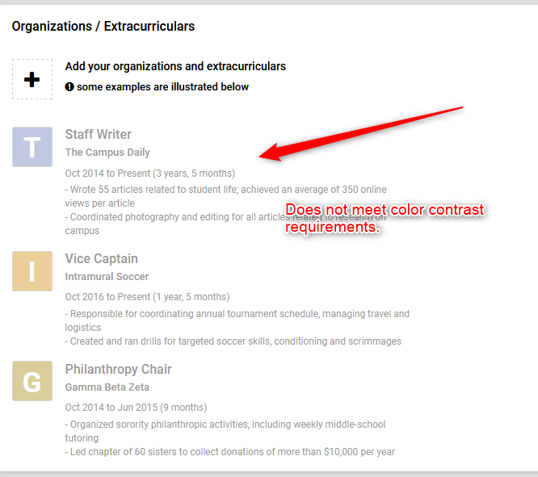
- Filters found throughout the site, Student section, Jobs, Applications, etc. do not pass color contrast requirements; the ratio is 3.4:1.
