Intro
This is the introduction. We like it a lot. So we will do it as much as possible
.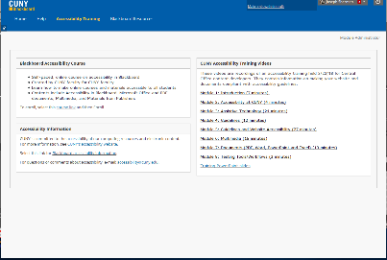
Step One
Do THIS AND THIS AND THIS
Step Two
THIS AND THIS AND THIS TOO
Step Three
This is the next step. We like it a lot. So we will do it as much as possible.
Step Four
Do THIS AND THIS AND THIS and all these things too.
Step Five
THIS AND THIS AND THIS TOO

