Archive and Clean Off The Echo Smart Pen
First, Archive the pen
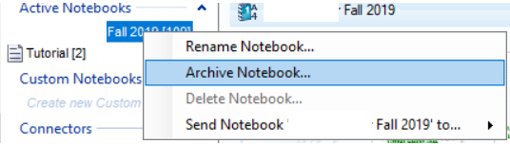
Click Archive
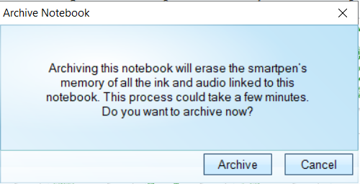
Once that is done, start the Smartpen Flash Utility. Make sure the pen shows up (in blue text). I just leave the Echo Desktop open as it will engage it anyway once the pen starts the process.
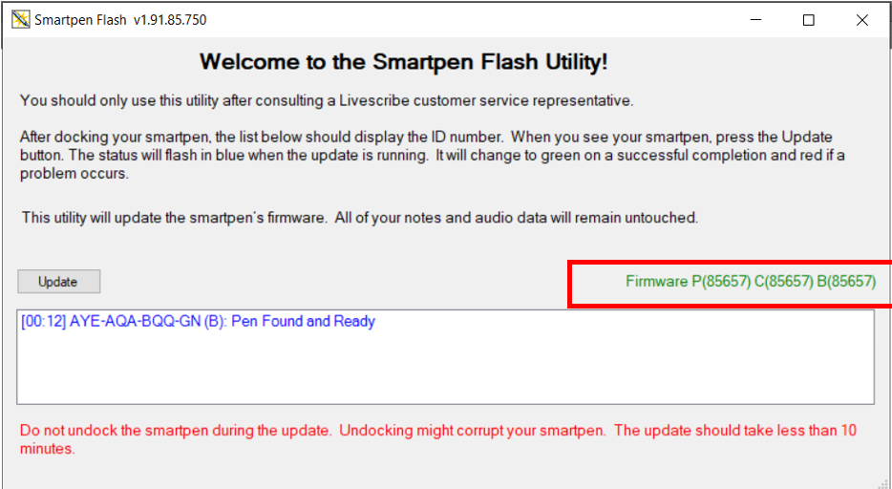

Click Yes
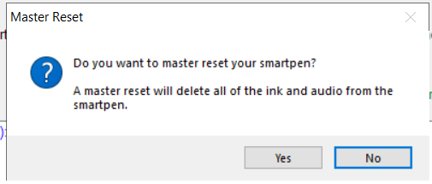
Now, Click update
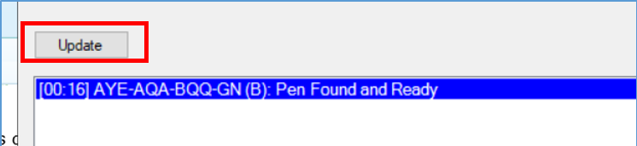

The process will flash blue until it is done. Then it will turn green to let you know it is done
Process still cleaning
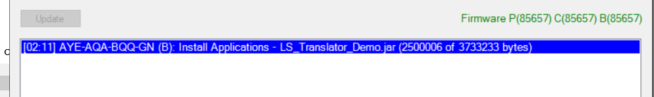

Process is now done.
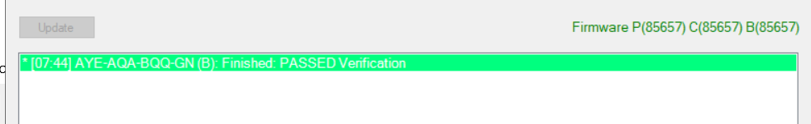
This process take about 5-10 minutes but when it is done, you can use the pen as it is clean and ready.

I also found that if your main storage folder gets too big, it will also cause problems with the pens.
Tutorial coming soon to fix this issue, too.

