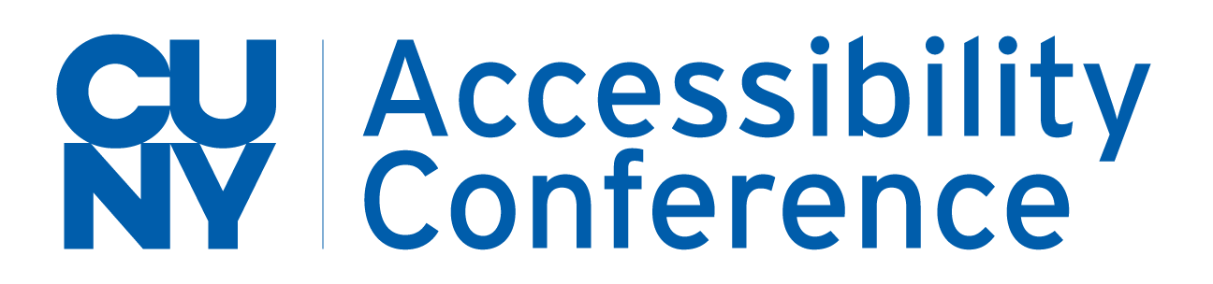

12th Annual CUNY Accessibility Conference

Call for Proposals

2021

Perspectives on Access: Innovations, Lessons Learned, and Looking Forward

Four Day Event, 2021

Tuesday, April 6th

Wednesday, April 7th

Thursday, April 8th

Friday, April 9th

The purpose of this document is to serve as a template for your proposal submission. In order for your proposal to be considered, please fill out the Presentation Proposal Form.

Proposals are due by February 16th, 2021 at 12:00pm. Presentations will be 50 minutes, including questions and answers. You will be notified by the committee regarding the acceptance of your proposal by February 23rd. For questions, please email Shivan Mahabir at shmahabir@qcc.cuny.edu.

CAC PROPOSAL SUBMISSION 2021

Presenter Information
Presentations may not exceed four presenters.

- First Presenter:

Name:
Job Title (will be listed in program):
Institution or Organization:
Phone:
E-Mail:
Bio (max. 100 words):

- Second Presenter:

Name:
Job Title (will be listed in program):
Institution or Organization:
Phone:
E-Mail:
Bio (max. 100 words):

- Third Presenter:

Name:
Job Title (will be listed in program):
Institution or Organization:
Phone:
E-Mail:
Bio (max. 100 words):

- Fourth Presenter:

Name:
Job Title (will be listed in program):
Institution or Organization:
Phone:
E-Mail:
Bio (max. 100 words):

Proposal Information

- Topical Areas (Select up to three that closely matches your proposal)

_____ Accessibility
_____ Accommodations / Disability Services
_____ Assistive Technology
_____ Campus Collaboration/Outreach
_____ COVID Impact
_____ Distance/Online Education
_____ Diversity/Social Justice
_____ Leadership & Advocacy
_____ Legal/Policies
_____ Promising Practices
_____ Research
_____ Student Life and Advocacy
_____ Transition to Employment
_____ Wellness
_____ Other -- If other, specify: _____________________________________

- Presentation Title: (15 words maximum)

- Presentation Abstract: (200 words maximum), to be used in conference registration materials

- Presentation Description: (500 words maximum) to be used in the review process

- Describe up to three learning goals and HOW you plan to achieve them. Video tutorial on writing learning goals.

- Learning Goal:
- Plan:
- Learning Goal:
- Plan:
- Learning Goal:
- Plan

10.If we receive other proposals on the same topic as yours, are you willing to partner in the presentation of information on that topic?

____ No
____ Yes, I am interested in partnering with other presenters to create a joined presentation.

- Preferred Time of Presentation.

_____ 11am Eastern Time
_____ 12pm Eastern Time
_____ Either is fine

