**English 242: Reading Short Stories**

*Science Fiction, Fantasy, & Americana*

Summer 2023, A-Term

Instructor: Carrie Matthews

Email: [crmatthe@uw.edu](mailto:crmatthe@uw.edu)

Office Hours: Mondays &Tuesdays, 10:30-11:30 (Via phone or Zoom)

or by appointment. Feel free to text me at 206-351-0214.

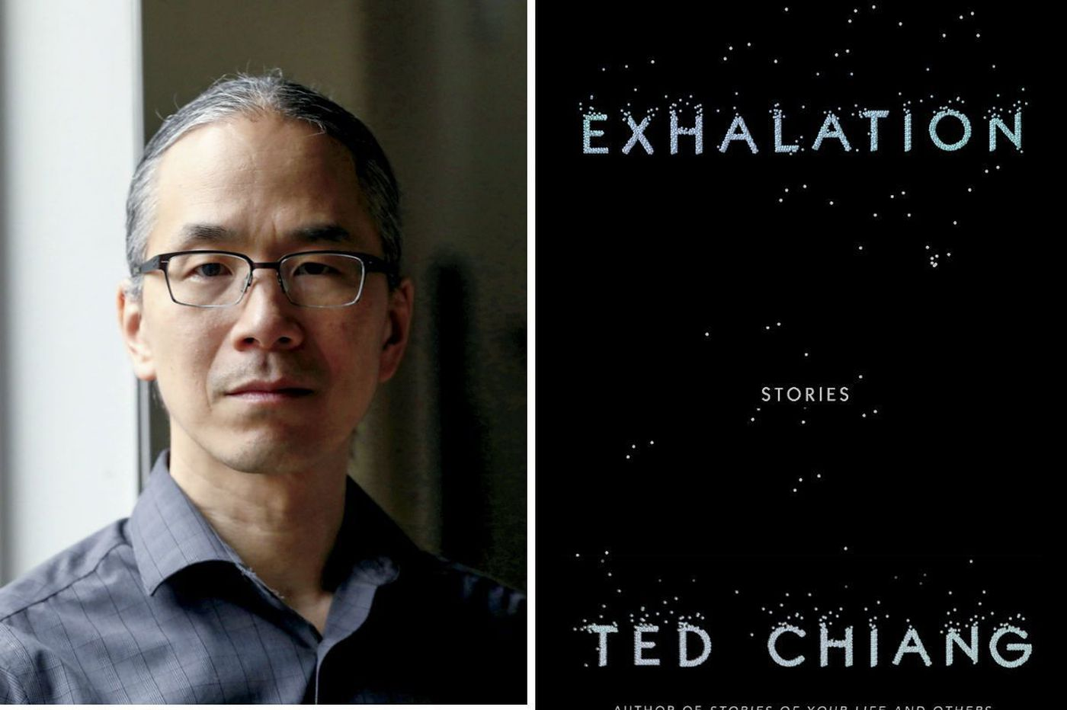 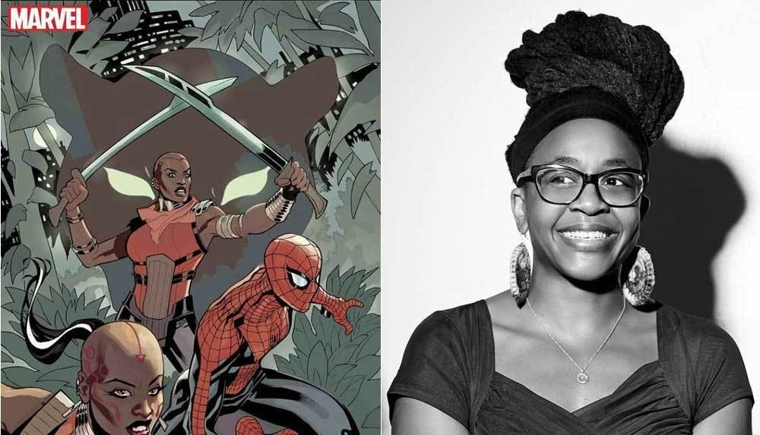

Ted Chiang Nnedi Okarafor, Wakanda Forever

**Texts**

All texts are available free online via urls on this syllabus or posted to our Canvas website under that day’s module. Texts not assigned but mentioned in mini-lectures will be added to the relevant module on Canvas.

**Course Overview**

Looking at the selection of short stories, with loose weekly foci on science fiction, fantasy, and Americana, I might joke that this course resulted from me watching too many “Black Mirror” episodes years ago. I selected the texts around two concerns: short story authors I wanted you to read, or me to read again, whose texts are available for free; and shared concerns of a sub-genre or theme. The bulk of our texts are of recent or contemporary vintage (20th or 21st century), and most are from the U.S.

This course counts for “W” or writing credit, and I’ve assigned a mix of informal and formal writing. On the informal side, you’ll write weekly reading responses and reading quizzes. These are designed to keep you on track with readings and, of course, for me to learn what you think of them, how you are processing them, etc. We will also have three conversations in small groups. Each group will decide if you want to have an actual conversation with me (for 30 minutes via Zoom) or do a written conversation via google docs. On the formal side, you’ll write one 5-8 page comparative analytical academic essay that productively brings two or more of the stories we have read into dialogue with one another, and conduct an independent composition project, either alone, with a partner, or in a small group. The independent project can be primarily analytical or creative: you could conduct a research project on an author’s work; you could write your own short story and reflection; you could practice multimodal writing and create a video or a podcast, etc. I’ve gotten some really interesting illustrations of a short story in the past, as well as a sculpture. I won’t be judging you on your artistic skills; I’ll focus on the reflection, the connection to a short story. The independent projects will take varying forms of varying lengths, and I will approve or suggest revisions to your project proposal by Friday, 7/7.

**Course Goals:**

1. To help you cultivate a love of reading fiction, if you don’t already have one, or expand that love to include exploring a lot of short stories.
2. To help you develop robust close reading or textual analysis practices
3. To use writing as a tool for actively reading and exploring short fiction
4. To produce independent projects that demonstrate significant learning about what short stories do, how they work, and how we read them.
5. To build a functioning intellectual community together despite us never ever actually being in the same room together.

**Class Community Norms**

Respect for Difference & Learning:For us to achieve the intellectual vibrancy diversity produces, we have to be open to learning how others see and move through the world, and we have to respect everyone's experiences. We should also recognize that some people's ways of seeing and experiencing the world have been privileged, while others have been marginalized, disparaged, and sometimes met with outright violence. We should attend to that in our written and oral commentary by engaging difference with openness to learning and awareness of power dynamics.  I expect each of us to help build a class community where sexist, racist, homophobic, transphobic, and ableist language and action are not welcomed so that all members of our class can be welcomed.

Sharing Writing: Our course includes three “conversations” with some classmates and me. They can be live via Zoom or written via google doc: each group decides how you want to proceed. Hopefully this goes without saying, but at the risk of redundancy, I’ll say (well, write) it: treat everyone and everyone’s work in this class with respect. In particular, when we discuss informal writing, focus on responding to ideas, and if you have a critique, remember that you’re critiquing the draft in front of you, not the writer. Please respect the parameters of our learning community and do not share your classmates’ writing with people outside the course unless you have their permission to do so in writing.

**\**

**Assignments:**

* Weekly Reading Responses: ………………………………………………20%
* Weekly Reading Quizzes: …………………………………………………10%
* Group Conversations: ……………………………………………………..20%
* Comparative Analytical Essay (1250-1750 words) bringing two short stories into dialogue ...…………………………………………………………… 25%
* Independent Project & Reflection (proposal required): …………………...25% _________

100%

**Nuts and Bolts**

Paper Format: Unless an assignment specifies otherwise, please submit all papers in 11- or 12-pt. Times New Roman font, double-spaced, with one-inch margins. Include your name, the date, and a title at the top of the first page: you don’t need a title page.

Plagiarism: Don’t do it! If you ever have questions about documentation, please come see me—I’m happy to help answer questions and share strategies for avoiding plagiarism. I do expect your words and the ideas they express to be your own except when you clearly signal and name another source.

**ACADEMIC RESOURCES & SUPPORT:**

**Accommodations:** Please let me know if you need accommodation of any sort. I am happy to work with the UW Disability Resources for Students Office (DRS) to provide what you require, and I am very willing to take suggestions specific to this class to meet your needs.

If you have already established accommodations with Disability Resources for Students (DRS), please communicate your approved accommodations to me at your earliest convenience so we can discuss your needs in this course.  
  
If you have not yet established services through DRS, but have a temporary health condition or permanent disability that requires accommodations (conditions include but not limited to; mental health, attention-related, learning, vision, hearing, physical or health impacts), you are welcome to contact DRS at 206-543-8924 or [uwdrs@uw.edu](mailto:uwdrs@uw.edu) or [disability.uw.edu](http://disability.uw.edu/). DRS offers resources and coordinates reasonable accommodations for students with disabilities and/or temporary health conditions. Reasonable accommodations are established through an interactive process between you, your instructor(s) and DRS. It is the policy and practice of the University of Washington to create inclusive and accessible learning environments consistent with federal and state law.

**Religious Accommodations**: “Washington state law requires that UW develop a policy for accommodation of student absences or significant hardship due to reasons of faith or conscience, or for organized religious activities. The UW’s policy, including more information about how to request an accommodation, is available at [Religious Accommodations Policy (https://registrar.washington.edu/staffandfaculty/religious-accommodations-policy/)](https://registrar.washington.edu/staffandfaculty/religious-accommodations-policy/). Accommodations must be requested within the first two weeks of this course using the [Religious Accommodations Request form (https://registrar.washington.edu/students/religious-accommodations-request/)](https://registrar.washington.edu/students/religious-accommodations-request/).”

I’m required to include the language above by (new) law in Washington. Basically, if any class demands conflict with a religious observance for you, I am happy to work with you. Please just let me know early in the quarter.

**Writing Centers**

Wherever you fall on the spectrum of writing in this course— whether you are struggling with a writing assignment or seeking to “reach the next level”— take advantage of the UW’s writing centers. It’s valuable to get the perspective of someone outside the course (especially someone with expertise in producing academic writing). UW’s writing centers are **free** for students and provide individual attention from trained readers and writing coaches. This quarter they will offer remote writing appointments.

The **Odegaard Writing and Research Center (OWRC)** offers free, one-on-one help with all aspects of writing at any stage in the writing process.You can consult with a writing tutor at any stage of the writing process, from the very beginning (when you are planning a paper) to near the end (when you are thinking about how to revise a draft to submit to your instructor). To make the best use of your time there, please bring a copy of your assignment with you to your online session. While OWRC writing consultants are eager to help you improve your writing, they will not proofread your paper. Available spots are limited, so **book your appointments early!** Reserve appointments online at <http://depts.washington.edu/owrc/> .

You can also try out the **CLUE Writing Center.** CLUE is a first-come, first-served writing center. To learn more and make an appointment, visit <http://depts.washington.edu/clue/dropintutor_writing.php>

### Confidentiality: Barring an imminent threat, I will not discuss you or your performance in this class with third parties outside the University of Washington unless you instruct me to do so and sign a consent form. FERPA (the Family Education Rights and Privacy Act) prevents me from legally disclosing student information to third parties without a release signed by you. And even if a third party (a potential employer, a government agency, etc.) contacts me for information about you and has a consent form that you have signed, I will still refrain from providing information unless you have given me a written request (email is fine). So: if you would like me to respond to queries about you from a potential employer or anyone else, you should do two things: 1) fill out and sign a release form (one the third party provides or the UW's own, found at <http://www.washington.edu/students/reg/ferpafac.html>); and 2) email me a request to talk with this third party, giving me a sense of the context (recommendation? background check?) and of any information I should be sure to reveal or not reveal.

**Q Center**

The University of Washington Q Center is a fierce, primarily [student run](http://depts.washington.edu/qcenter/wordpress/about-us/staff/) resource center dedicated to serving anyone with or without a gender or sexuality – UW students, staff, faculty, alum, and community members.  We host and support [student groups](http://depts.washington.edu/qcenter/wordpress/trans-gender-queering-support-group/), put on regular programming [events](http://depts.washington.edu/qcenter/wordpress/events/), house a lending [library](http://depts.washington.edu/qcenter/wordpress/resources/library/)*,* and amplify student voices on our [Student Blog](http://depts.washington.edu/qcenter/wordpress/blog/).  Explore their website for more information: http://depts.washington.edu/qcenter/wordpress/

**Voter Registration**

You can register to vote online or by mail until 8 days before an election or in-person through Election day. Registrations done by mail need to be received, not postmarked, by the 8-day deadline.

Out-of-state students may register to vote in Washington if you have lived in the state for at least 30 days and have established a residential address in the state.

For more information, check out

See <https://www.kingcounty.gov/depts/elections/how-to-vote/register-to-vote.aspx>

**Course Calendar & Texts**

**Unit One: Practices of Close Reading Short Stories**

T 6/20 Course Introduction & Introduction to Close Reading. Lydia Davis, “The Mother” <https://apersonalanthology.com/2022/05/13/the-mother-by-lydia-davis/>

(The one paragraph of italicized text comprises the entire literary text!)

W 6/21 Haruki Marukami, “On Seeing the 100% Perfect Girl One Beautiful April Morning”

<https://genius.com/Haruki-murakami-on-seeing-the-100-perfect-girl-one-beautiful-april-morning-annotated>

Critical Reading: Jonathan Culler, “The Closeness of Close Reading”

<http://www.mrshaughaboo.com/uploads/1/8/9/5/18950307/8.culler_on_close_reading.pdf>

Reading Quiz #1

Th 6/22 On Irony: Guy de Maupassant, “The Necklace”

<https://fac.ksu.edu.sa/sites/default/files/the_diamond_necklace.pdf>

Kate Chopin, “The Story of An Hour”

<https://archive.vcu.edu/english/engweb/webtexts/hour/>

Reading Response #1

M 6/26 Unreliable Narrators, Part 1: Edgar Allan Poe, “The Black Cat”

<https://poestories.com/read/blackcat>

T 6/27 Unreliable Narrators, Part 2: Charles Baudelaire,

“The Rope”

<https://exchanges.uiowa.edu/issues/estranged/the-rope/>

and “Beat Up the Poor!”

<http://baudelairepoems.blogspot.com/>

Group Conversation #1

**Unit Two: Science Fiction**

W 6/28 Isaac Asimov, “Nightfall” <https://sites.uni.edu/morgans/astro/course/nightfall.pdf>

Critical Reading: Leah Zaidi, “Worldbuilding in Science Fiction, Foresight and Design”

<https://jfsdigital.org/wp-content/uploads/2019/06/03-Zaidi-Worldbuilding.pdf>

Reading Quiz #2

Th 6/29 Octavia Butler, “The Book of Martha”

<https://www.sevenstories.com/blogs/102-an-exclusive-short-story-from-octavia-butler-in-celebration-of-her-birthday>

Reading Response #2

M 7/3 Ursula K. Le Guin, “The Ones Who Walk Away From Omelas”

<https://www.utilitarianism.com/nu/omelas.pdf>

*Independent Project Proposal Due*

T 7/4, N.K. Jemisin,"The Ones Who Stay and Fight"

<http://www.lightspeedmagazine.com/fiction/the-ones-who-stay-and-fight/>

Group Conversation #2

W 7/5 Ted Chiang, “Exhalation”

<http://www.lightspeedmagazine.com/fiction/exhalation/>

Reading Quiz #3

**Unit Three: Fantasy**

Th 7/6, Critical Reading: Hatice Eşberk, “The Function of Fantasy as a Subversive Genre in Literature” (Posted on Modules on Canvas as a pdf file)

Reading Response #3

M 7/10, Nnedi Okorafor, “Spider the Artist”

<http://www.lightspeedmagazine.com/fiction/spider-the-artist/>

Group Conversation #2

T 7/11 N. K. Jemisin, “The City Born Great”

<https://www.tor.com/2016/09/28/the-city-born-great/>

**\*Comparative Analytical Essay Due\***

W 7/12 Daisy Johnson, “A Bruise the Size and Shape of a Door Handle” (includes audiorecording of a reading)

<http://americanshortfiction.org/new/bruise-size-shape-door-handle/>

Reading Quiz #4

**Unit Four: Americana**

Th 7/13 Tommy Orange, “The Team” (provided under the Canvas Module)

Brief interview with Tommy Orange on the PBS Newshour

<https://www.youtube.com/watch?v=JXCbmuIFD8M>

Reading Response #4

M 7/17 Toni Morrison, “Sweetness”

<https://www.newyorker.com/magazine/2015/02/09/sweetness-2>

Critical Reading: Sandy Grande, “Refusing the University”

<https://www.uvicfa.ca/wp-content/uploads/2020/11/Refusing_the_University.pdf>

T 7/18 Viet Thanh Nguyen, “Fatherland”

<https://vietnguyen.info/wp-content/uploads/2013/07/NguyenViet_Fatherland.pdf>

Short film “American Refugee”

<https://www.youtube.com/watch?v=maFi7OMfg7A>

Group Conversation #3

W 7/19 Celeste Ng, “Girls, At Play”

<https://blreview.org/fiction/girls-at-play/>

**Independent Project & Reflection Due**