HOW DO THEY DO IT? WHAT WERE THEY THINKING?

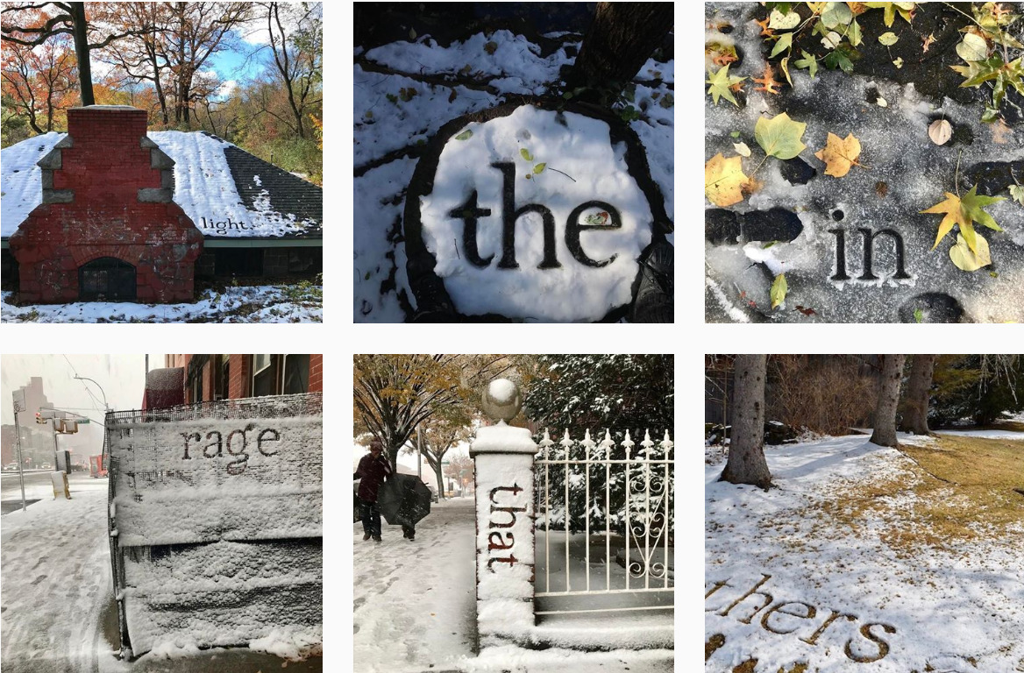
Photo credit: Shelley Jackson, as @snowshelleyjackson on Instagram

WRITERS ON WRITING (ENGL 285)

Winter 2024 Mon/Wed 9:30-11:20 In-person Professor Maya Sonenberg

- A&H credit, W credit, 5 Credits
- Meet and chat with UW Creative Writing faculty and other fiction writers, poets, and nonfiction writers
- Opportunities for small group work & feedback on your writing
- Assignments: brief responses to the talks and reading, creative writing exercises
- Questions? Ask me! mayas@uw.edu
- More info about me: https://mayasonenberg.com/ & https://english.washington.edu/people/maya-sonenberg

Student Endorsements
- “If I had taken this class as a 1st year, I would be a creative writing major. It’s SO COOL.”
- “In other creative writing classes, it can be intimidating if you have little to no experience…. But this course leaves more room for rough drafts, so it’s a great intro.”
- “The variety of prompts & speakers did a great job of pulling me just slightly out of my comfort zone, enough to learn quite a bit without being stressed out.”
- “Everyone should be able to benefit from creative writing—from self-exploration to enhanced perception of the world to increased overall writing ability—they should, of course, take this class.”
- “Eye-opening in many ways—especially the different stories being shared.”

